**Predictors of enhancing one’s physical attractiveness: Data from 93 countries**

**Supplementary Material**

Contents

Instruction for the translators when translating the survey into local languages 4

Detailed participants’ descriptive characteristics 5

Data collection 6

Table S1. Detailed participants’ descriptive characteristics across countries. 7

Statistical analyses–equivalence of invariance 11

Pilot study 11

Packages used in R 12

Table S2. Correlations across the variables of interest. 14

Figure S1. Standardized time spent on beauty-enhancing behaviors across countries and sex/gender. 15

Figure S2. Standardized time spent applying make-up across countries and sex/gender. 16

Figure S3. Standardized time spent on cosmetics usage across countries and sex. 17

Figure S4. Standardized time spent exercising across countries and sex. 18

Figure S5. Standardized time spent on hair grooming across countries and sex. 19

Figure S6. Standardized time spent on body hygiene across countries and sex. 20

Figure S7. Standardized time spent caring for dress across countries and sex. 21

Figure S8. Standardized time spent caring for diet across countries and sex. 22

Figure S9. Standardized time spent on other activities aimed to increase one’s physical attractiveness across countries and sex. 23

Table S3. Results of the measurements of the equivalence of invariance with respect to gender equality. 24

Table S4. Results of the measurements of the equivalence of invariance with respect to individualism. 25

Table S5. Results of the multilevel linear model regressing time spent on beauty-enhancing behaviors (the basic index with four categories) on countries’ Gross Domestic Product (GDP) per capita, countries’ individualism score, countries’ gender equality score, countries’ pathogen prevalence score, sex, age, age2, relationship status, time spent on social media, watching TV, self-assessed attractiveness, attained education, socioeconomic status, political views, individual-level individualism score, individual-level traditional gender roles score, and individual-level history of pathogenic diseases, with participants nested within countries. 26

Table S6. Results of the multilevel linear model regressing time spent exercising on countries’ Gross Domestic Product (GDP) per capita, countries’ individualism score, countries’ gender equality score, countries’ pathogen prevalence score, sex, age, age2, relationship status, time spent on social media, watching TV, self-assessed attractiveness, attained education, socioeconomic status, political views, individual-level individualism score, individual-level traditional gender roles score, and individual-level history of pathogenic diseases, with participants nested within countries. 27

Table S7. Results of the multilevel linear model regressing time spent enhancing physical attractiveness (the extended index with eight categories) on variables of interest, with interactions with gender (participants were nested within countries). 28

Table S8. Results of the multilevel linear model regressing time spent enhancing physical attractiveness on freed first-level predictors, with participants nested within countries. 29

Table S9. Results of the multilevel linear model regressing time spent enhancing physical attractiveness among men, with participants nested within countries. 30

Table S10. Results of the multilevel linear model regressing time spent enhancing physical attractiveness among women, with participants nested within countries. 31

Figure S10. Standardized predicted time spent enhancing physical attractiveness across gender and age (controlling for other predictors from the model, see Table S7). 32

Figure S11. Standardized predicted time spent enhancing physical attractiveness across gender and relationship status (controlling for other predictors from the model, see Table S7). 33

Figure S12. Standardized predicted time spent enhancing physical attractiveness across gender and time spent watching TV (controlling for other predictors from the model, see Table S7). 34

Figure S13. Standardized predicted time spent enhancing physical attractiveness across gender and time spent on social media (controlling for other predictors from the model, see Table S7). 35

Figure S14. Standardized predicted time spent enhancing physical attractiveness across gender and self-assessed physical attractiveness (controlling for other predictors from the model, see Table S7). 36

Figure S15. Standardized predicted time spent enhancing physical attractiveness across gender and participants’ endorsement of gender roles (controlling for other predictors from the model, see Table S7). 37

Figure S16. Standardized predicted time spent enhancing physical attractiveness across gender and participants’ attained level of education (controlling for other predictors from the model, see Table S7). 38

Figure S17. Standardized predicted time spent enhancing physical attractiveness across gender and participants’ political beliefs (controlling for other predictors from the model, see Table S7). 39

Figure S18. Standardized predicted time spent enhancing physical attractiveness across gender and countries’ gross domestic product (GDP) per capita (controlling for other predictors from the model, see Table S7). 40

Figure S19. Standardized predicted time spent enhancing physical attractiveness across gender and countries’ historic pathogen prevalence (controlling for other predictors from the model, see Table S7). 41

Table S11. Results of the multilevel linear model regressing time spent enhancing physical attractiveness on variables of interest with the addition of quadratic self-assessed physical attractiveness, with participants nested within countries. 42

Figure S20. Non-linear relationship between standardized time spent enhancing one’s physical attractiveness and self-assessed physical attractiveness. 43

Table S12. Results of the multilevel linear model regressing the first factor of activities aimed at increasing one’s physical attractiveness on predictor variables (with participants nested within countries). 43

Table S13. Results of the multilevel linear model regressing the second factor of activities aimed at increasing one’s physical attractiveness on predictor variables (with participants nested within countries). 44

Time spent on beauty enhancing behaviors across men and women 45

Figure S21. Time spent on cosmetics usage across age. 45

Figure S22. Time spent on makeup usage across age (among women). 46

Figure S23. Time spent caring for hygiene across age. 47

Figure S24. Time spent caring for hair across age. 48

Figure S25. Time spent exercising across age. 49

Figure S26. Time spent caring for dress across age. 50

Figure S27. Time spent caring for diet across age. 51

Figure S28. Time spent on other activities aimed at increasing one’s attractiveness across age. 51

Survey 52

# Instruction for the translators when translating the survey into local languages

How should the translation look?

We follow the guidelines of WHO (https://www.who.int/substance_abuse/research_tools/translation/en/). In brief:

1. At least one (ideally more than one) person will do a forward translation (from English to your native language). If more than one person is involved in this part, they work together and discuss all issues. Once this is done, it is time for:

2. At least one (ideally more than one) person will now take the version of the questionnaire translated by the other team and translate this version back to English from your native language. If more than one person is involved in this part, they work together and discuss all issues. Once this is done, it is time for:

3. At the end, all translators compare two versions of the questionnaire and spot any differences. Please, at this point, try to figure out why such differences appeared. Do they substantially change the meaning? Maybe some questions would need slight alterations? Our goal is to investigate psychological phenomena. Thus, the equivalence of our measures is super important. If we do not achieve the equivalence of invariance, we would not draw any conclusions from our study, as any potential differences between our participants from different countries would be attributed to the differences in measures and not underlying across individuals or countries factors.

4. Please, copy the final version into the sheet called “FINAL” and let me know. I will then upload your translation into Qualtrics and send you the link to the study. I will then ask you to make sure that everything is ok and nothing got lost or twisted in the process.

5. IMPORTANT THINGS:

During the translation, one of the most essential things would be to translate the questions/items but WITHOUT changing anything else. I know that the excel file looks a bit messy, but that is because it has some HTML formatting inserted (so to make our survey look more visually appealing). If you, by accident, delete some “<” signs, it will result in errors in the layout of the study. So please, translate ONLY English words and ignore the rest, leaving it unaltered (as shown in the excel file, sheet “INSTRUCTIONS”).

If the local language in your country is SIMILAR (or identical) to languages of other countries (e.g., Spanish, Portuguese), please, let me know. I can then assign you to the given language translation group (so you would join forces).

All the best,  
Marta

# Detailed participants’ descriptive characteristics

There were 75,807 (81.4%) self-reported heterosexuals, 6,911 (7.4%) bisexuals, 3,854 (4.2%) individuals who preferred not to indicate their sexual orientation, 1,823 (2%) male homosexuals, 1,584 (1.7%) pansexuals, 1,257 lesbians (1.3%), 1,028 (1.1%) individuals who answered ‘other’, and 894 (1%) asexuals. As for education level, 37,733 (40.5%) had a bachelor’s degree, 18,919 (20.3%) completed 12 years of school, 17,496 (18.8%) had a master’s degree, 7,983 (8.57%) did not answer this item, 5,284 (5.7%) held a PhD/doctorate, 5,070 (5.4%) completed 9 years of school, 437 (0.5%) completed 6 years of school, and 236 (0.3%) individuals did not have any formal education.

# Data collection

Data were collected mostly online in all but two countries*,* as participants from Algeria and Morocco could not access the Qualtrics website. Thus, collaborators collected data in person using a paper-pencil method. Furthermore, Iranian participants also had difficulties accessing the Qualtrics website, so we re-created the survey and collected data using Google Forms. One Russian Collaborator collected data using the Toloka website (a crowdsourcing platform popular in Russia)*.*

# Table S1. Detailed participants’ descriptive characteristics across countries.

|  |  |  |  |  |  |  |  |  |  |  |  |  |  |  |  |  |
| --- | --- | --- | --- | --- | --- | --- | --- | --- | --- | --- | --- | --- | --- | --- | --- | --- |
| **Country** | **n** | **Age** | | **Sex** | | **Relationship status** | | | | **Education** | | | | | | |
|  |  | **M** | **SD** | **Men (%)** | **Women (%)** | **Single (%)** | **Dating (%)** | **In a committed relationship (%)** | **Married (%)** | **No formal education (%)** | **Primary school only (%)** | **Primary school through Secondary school (%)** | **Primary school through High school or Technical college (%)** | **Primary school through Bachelor's degree (%)** | **Primary school through Master's degree (%)** | **Primary school through PhD, MD, JD, or other advanced degree (%)** |
| Albania | 40 | 24.62 | 6.28 | 27 (67.5%) | 13 (32.5%) | 18 (45%) | 5 (12.5%) | 14 (35%) | 3 (7.5%) | 0 (0%) | 0 (0%) | 1 (2.5%) | 5 (12.5%) | 15 (37.5%) | 11 (27.5%) | 3 (7.5%) |
| Algeria | 1570 | 28.24 | 9.76 | 516 (32.9%) | 1046 (66.6%) | 516 (32.9%) | 379 (24.1%) | 232 (14.8%) | 443 (28.2%) | 10 (0%) | 35 (0%) | 95 (6.1%) | 176 (11.2%) | 279 (17.8%) | 583 (37.1%) | 376 (23.9%) |
| Angola | 102 | 34.34 | 9.35 | 65 (63.7%) | 36 (35.3%) | 21 (20.6%) | 14 (13.7%) | 14 (13.7%) | 53 (52%) | 3 (0%) | 0 (0%) | 1 (1%) | 3 (2.9%) | 53 (52%) | 15 (14.7%) | 9 (8.8%) |
| Argentina | 2040 | 46 | 16.88 | 844 (41.4%) | 1170 (57.4%) | 853 (41.8%) | 311 (15.2%) | 165 (8.1%) | 695 (34.1%) | 14 (0%) | 19 (0%) | 247 (12.1%) | 256 (12.5%) | 690 (33.8%) | 173 (8.5%) | 101 (5%) |
| Australia | 494 | 31.91 | 11.88 | 218 (44.1%) | 265 (53.6%) | 203 (41.1%) | 33 (6.7%) | 154 (31.2%) | 104 (21.1%) | 0 (0%) | 3 (0%) | 22 (4.5%) | 112 (22.7%) | 179 (36.2%) | 94 (19%) | 38 (7.7%) |
| Austria | 211 | 28.88 | 9.92 | 56 (26.5%) | 147 (69.7%) | 74 (35.1%) | 12 (5.7%) | 91 (43.1%) | 33 (15.6%) | 3 (0%) | 0 (0%) | 8 (3.8%) | 28 (13.3%) | 76 (36%) | 61 (28.9%) | 11 (5.2%) |
| Azerbaijan | 44 | 21.77 | 5.08 | 30 (68.2%) | 13 (29.5%) | 36 (81.8%) | 6 (13.6%) | 2 (4.5%) | #N/D | 1 (0%) | 0 (0%) | 1 (2.3%) | 6 (13.6%) | 26 (59.1%) | 7 (15.9%) | 0 (0%) |
| Bahrain | 73 | 27.92 | 7.24 | 46 (63%) | 27 (37%) | 40 (54.8%) | 7 (9.6%) | 3 (4.1%) | 23 (57.5%) | 1 (0%) | 2 (0%) | 1 (1.4%) | 4 (5.5%) | 27 (37%) | 21 (28.8%) | 6 (15%) |
| Bangladesh | 46 | 23.26 | 5.42 | 35 (76.1%) | 10 (21.7%) | 30 (65.2%) | 3 (6.5%) | 8 (17.4%) | 5 (0.3%) | 1 (0%) | 1 (0%) | 4 (8.7%) | 14 (30.4%) | 16 (34.8%) | 5 (10.9%) | 0 (0%) |
| Belarus | 139 | 25.55 | 10.37 | 40 (28.8%) | 93 (66.9%) | 74 (53.2%) | 23 (16.5%) | 29 (20.9%) | 13 (12.7%) | 1 (0%) | 0 (0%) | 20 (14.4%) | 24 (17.3%) | 56 (40.3%) | 17 (12.2%) | 7 (0.4%) |
| Belgium | 2355 | 44.55 | 18.22 | 982 (41.7%) | 1366 (58%) | 706 (30%) | 83 (3.5%) | 678 (28.8%) | 887 (43.5%) | 10 (0%) | 26 (0%) | 260 (11%) | 599 (25.4%) | 632 (26.8%) | 575 (24.4%) | 77 (75.5%) |
| Bolivia | 78 | 24.81 | 8.09 | 24 (30.8%) | 54 (69.2%) | 39 (50%) | 29 (37.2%) | 4 (5.1%) | 6 (1.2%) | 0 (0%) | 0 (0%) | 4 (5.1%) | 8 (10.3%) | 35 (44.9%) | 8 (10.3%) | 3 (0.1%) |
| Bosnia and Herzegovina | 450 | 27.33 | 9.63 | 94 (20.9%) | 354 (78.7%) | 204 (45.3%) | 41 (9.1%) | 111 (24.7%) | 94 (44.5%) | 0 (0%) | 1 (0%) | 49 (10.9%) | 28 (6.2%) | 132 (29.3%) | 127 (28.2%) | 61 (12.3%) |
| Brazil | 1757 | 30.21 | 10.38 | 676 (38.5%) | 1063 (60.5%) | 774 (44.1%) | 157 (8.9%) | 485 (27.6%) | 340 (850%) | 2 (0%) | 3 (0%) | 7 (0.4%) | 233 (13.3%) | 898 (51.1%) | 229 (13%) | 136 (64.5%) |
| Brunei | 312 | 25.9 | 5.99 | 130 (41.7%) | 179 (57.4%) | 162 (51.9%) | 33 (10.6%) | 56 (17.9%) | 61 (3.9%) | 0 (0%) | 0 (0%) | 5 (1.6%) | 51 (16.3%) | 162 (51.9%) | 38 (12.2%) | 7 (17.5%) |
| Bulgaria | 281 | 25.33 | 7.61 | 60 (21.4%) | 217 (77.2%) | 87 (31%) | 25 (8.9%) | 143 (50.9%) | 25 (24.5%) | 1 (0%) | 1 (0%) | 9 (3.2%) | 137 (48.8%) | 68 (24.2%) | 43 (15.3%) | 5 (0.3%) |
| Canada | 830 | 32.14 | 10.68 | 368 (44.3%) | 440 (53%) | 299 (36%) | 75 (9%) | 226 (27.2%) | 228 (11.2%) | 1 (0%) | 3 (0%) | 29 (3.5%) | 200 (24.1%) | 404 (48.7%) | 132 (15.9%) | 34 (33.3%) |
| Chile | 2472 | 29.86 | 7.24 | 418 (16.9%) | 1978 (80%) | 854 (34.5%) | 792 (32%) | 534 (21.6%) | 290 (58.7%) | 2 (0%) | 0 (0%) | 36 (1.5%) | 147 (5.9%) | 1221 (49.4%) | 492 (19.9%) | 111 (5.4%) |
| China | 104 | 26.5 | 8.61 | 46 (44.2%) | 55 (52.9%) | 58 (55.8%) | 9 (8.7%) | 23 (22.1%) | 14 (6.6%) | 0 (0%) | 0 (0%) | 5 (4.8%) | 4 (3.8%) | 58 (55.8%) | 16 (15.4%) | 15 (3%) |
| Colombia | 813 | 28.4 | 13.08 | 272 (33.5%) | 535 (65.8%) | 403 (49.6%) | 224 (27.6%) | 66 (8.1%) | 118 (295%) | 2 (0%) | 2 (0%) | 49 (6%) | 177 (21.8%) | 306 (37.6%) | 128 (15.7%) | 45 (21.3%) |
| Croatia | 2097 | 27.39 | 11.13 | 459 (21.9%) | 1615 (77%) | 876 (41.8%) | 202 (9.6%) | 730 (34.8%) | 288 (18.3%) | 1 (0%) | 8 (0%) | 983 (46.9%) | 164 (7.8%) | 385 (18.4%) | 374 (17.8%) | 66 (165%) |
| Cyprus | 210 | 30.46 | 10.77 | 87 (41.4%) | 123 (58.6%) | 71 (33.8%) | 18 (8.6%) | 66 (31.4%) | 55 (53.9%) | 1 (0%) | 1 (0%) | 7 (3.3%) | 21 (10%) | 84 (40%) | 54 (25.7%) | 28 (1.8%) |
| Czech Republic | 1167 | 26.99 | 8.5 | 281 (24.1%) | 878 (75.2%) | 376 (32.2%) | 167 (14.3%) | 456 (39.1%) | 168 (8.2%) | 0 (0%) | 3 (0%) | 345 (29.6%) | 65 (5.6%) | 345 (29.6%) | 252 (21.6%) | 41 (40.2%) |
| Denmark | 497 | 27.4 | 8.27 | 105 (21.1%) | 387 (77.9%) | 183 (36.8%) | 24 (4.8%) | 220 (44.3%) | 70 (14.2%) | 0 (0%) | 1 (0%) | 3 (0.6%) | 43 (8.7%) | 197 (39.6%) | 163 (32.8%) | 28 (1.4%) |
| Dominican Republic | 579 | 26.15 | 10.88 | 179 (30.9%) | 396 (68.4%) | 289 (49.9%) | 148 (25.6%) | 41 (7.1%) | 101 (47.9%) | 3 (0%) | 2 (0%) | 36 (6.2%) | 104 (18%) | 262 (45.3%) | 65 (11.2%) | 29 (5.9%) |
| Ecuador | 1606 | 30.08 | 11.46 | 684 (42.6%) | 916 (57%) | 673 (41.9%) | 423 (26.3%) | 118 (7.3%) | 388 (970%) | 7 (0%) | 22 (0%) | 187 (11.6%) | 305 (19%) | 643 (40%) | 259 (16.1%) | 113 (53.6%) |
| Egypt | 74 | 25.74 | 5.75 | 41 (55.4%) | 33 (44.6%) | 40 (54.1%) | 3 (4.1%) | 10 (13.5%) | 21 (1.3%) | 0 (0%) | 1 (0%) | 0 (0%) | 9 (12.2%) | 31 (41.9%) | 18 (24.3%) | 5 (12.5%) |
| El Salvador | 213 | 25.16 | 9.91 | 92 (43.2%) | 117 (54.9%) | 98 (46%) | 82 (38.5%) | 6 (2.8%) | 26 (25.5%) | 1 (0%) | 3 (0%) | 16 (40%) | 36 (16.9%) | 130 (61%) | 24 (11.3%) | 2 (0.1%) |
| Estonia | 467 | 34.21 | 12.49 | 70 (15%) | 391 (83.7%) | 173 (37%) | 74 (15.8%) | 123 (26.3%) | 97 (4.8%) | 0 (0%) | 1 (0%) | 5 (0.3%) | 164 (35.1%) | 115 (24.6%) | 125 (26.8%) | 18 (17.6%) |
| Finland | 909 | 32.58 | 11.01 | 160 (17.6%) | 701 (77.1%) | 278 (30.6%) | 45 (5%) | 390 (42.9%) | 196 (39.7%) | 1 (0%) | 0 (0%) | 6 (5.9%) | 167 (18.4%) | 290 (31.9%) | 260 (28.6%) | 77 (3.8%) |
| France | 2483 | 28.97 | 11.59 | 607 (24.4%) | 1814 (73.1%) | 1060 (42.7%) | 281 (11.3%) | 909 (36.6%) | 233 (110.4%) | 2 (0%) | 4 (0%) | 11 (0.5%) | 365 (14.7%) | 941 (37.9%) | 655 (26.4%) | 173 (35%) |
| Georgia | 748 | 24.58 | 10.54 | 158 (21.1%) | 573 (76.6%) | 488 (65.2%) | 57 (7.6%) | 94 (12.6%) | 108 (270%) | 3 (0%) | 8 (0%) | 97 (19.6%) | 72 (9.6%) | 358 (47.9%) | 80 (10.7%) | 39 (18.5%) |
| Germany | 733 | 29.66 | 10.29 | 230 (31.4%) | 485 (66.2%) | 268 (36.6%) | 63 (8.6%) | 236 (32.2%) | 165 (10.5%) | 2 (0%) | 3 (0%) | 37 (17.5%) | 171 (23.3%) | 203 (27.7%) | 198 (27%) | 55 (137.5%) |
| Ghana | 306 | 33.58 | 13.61 | 285 (93.1%) | 17 (5.6%) | 83 (27.1%) | 28 (9.2%) | 11 (3.6%) | 183 (179.4%) | 10 (0%) | 17 (0%) | 165 (375%) | 81 (26.5%) | 16 (5.2%) | 3 (1%) | 0 (0%) |
| Greece | 1219 | 29.26 | 11.17 | 169 (13.9%) | 1037 (85.1%) | 491 (40.3%) | 81 (6.6%) | 420 (34.5%) | 227 (11.1%) | 1 (0%) | 1 (0%) | 3 (4.1%) | 108 (8.9%) | 592 (48.6%) | 319 (26.2%) | 81 (5.2%) |
| Guatemala | 73 | 36.23 | 10.41 | 25 (34.2%) | 47 (64.4%) | 27 (37%) | 12 (16.4%) | 7 (9.6%) | 27 (5.5%) | 2 (0%) | 0 (0%) | 0 (0%) | 4 (5.5%) | 20 (27.4%) | 29 (39.7%) | 8 (7.8%) |
| Honduras | 850 | 26.32 | 8.44 | 242 (28.5%) | 601 (70.7%) | 406 (47.8%) | 251 (29.5%) | 63 (7.4%) | 127 (60.2%) | 7 (0%) | 9 (0%) | 70 (152.2%) | 93 (10.9%) | 465 (54.7%) | 77 (9.1%) | 31 (1.5%) |
| Hungary | 725 | 27.32 | 10.51 | 139 (19.2%) | 574 (79.2%) | 222 (30.6%) | 38 (5.2%) | 329 (45.4%) | 136 (340%) | 0 (0%) | 0 (0%) | 4 (2.9%) | 211 (29.1%) | 277 (38.2%) | 118 (16.3%) | 50 (10.1%) |
| India | 711 | 28.6 | 8.48 | 409 (57.5%) | 297 (41.8%) | 336 (47.3%) | 49 (6.9%) | 117 (16.5%) | 209 (13.3%) | 3 (0%) | 3 (0%) | 10 (0.4%) | 38 (5.3%) | 297 (41.8%) | 210 (29.5%) | 66 (31.3%) |
| Indonesia | 35 | 24.43 | 6.04 | 16 (45.7%) | 18 (51.4%) | 24 (68.6%) | 3 (8.6%) | 3 (8.6%) | 5 (4.9%) | 1 (0%) | 0 (0%) | 0 (0%) | 3 (8.6%) | 24 (68.6%) | 3 (8.6%) | 1 (2.5%) |
| Iran | 507 | 30.27 | 9.18 | 165 (32.5%) | 337 (66.5%) | 228 (45%) | 84 (16.6%) | 35 (6.9%) | 160 (7.8%) | 0 (0%) | 1 (0%) | 3 (3.8%) | 93 (18.3%) | 198 (39.1%) | 154 (30.4%) | 57 (3.6%) |
| Ireland | 384 | 34.87 | 9.75 | 99 (25.8%) | 279 (72.7%) | 113 (29.4%) | 20 (5.2%) | 105 (27.3%) | 146 (29.6%) | 1 (0%) | 1 (0%) | 39 (8.7%) | 79 (20.6%) | 157 (40.9%) | 83 (21.6%) | 15 (14.7%) |
| Israel | 1085 | 33.51 | 13.31 | 395 (36.4%) | 686 (63.2%) | 354 (32.6%) | 76 (7%) | 240 (22.1%) | 415 (196.7%) | 3 (0%) | 1 (0%) | 16 (0.9%) | 434 (40%) | 466 (42.9%) | 114 (10.5%) | 27 (1.3%) |
| Italy | 4704 | 33.34 | 13.77 | 1173 (24.9%) | 3497 (74.3%) | 1486 (31.6%) | 409 (8.7%) | 2038 (43.3%) | 769 (1922.5%) | 1 (0%) | 7 (0%) | 111 (35.6%) | 1107 (23.5%) | 1224 (26%) | 1288 (27.4%) | 359 (72.7%) |
| Jamaica | 57 | 37.53 | 11.31 | 12 (21.1%) | 44 (77.2%) | 23 (40.4%) | 4 (7%) | 7 (12.3%) | 23 (1.5%) | 1 (0%) | 0 (0%) | 0 (0%) | 4 (7%) | 15 (26.3%) | 28 (49.1%) | 6 (2.8%) |
| Japan | 1920 | 40.95 | 11.87 | 969 (50.5%) | 914 (47.6%) | 783 (40.8%) | 244 (12.7%) | 18 (0.9%) | 874 (856.9%) | 2 (0%) | 1 (0%) | 26 (9.3%) | 731 (38.1%) | 1010 (52.6%) | 106 (5.5%) | 23 (57.5%) |
| Jordan | 57 | 26.63 | 7.53 | 41 (71.9%) | 15 (26.3%) | 43 (75.4%) | 1 (1.8%) | 4 (7%) | 9 (0.4%) | 0 (0%) | 0 (0%) | 1 (0.1%) | 9 (15.8%) | 23 (40.4%) | 7 (12.3%) | 7 (0.4%) |
| Kazakhstan | 785 | 29.38 | 11.16 | 214 (27.3%) | 569 (72.5%) | 378 (48.2%) | 93 (11.8%) | 72 (9.2%) | 242 (49%) | 4 (0%) | 3 (0%) | 20 (0.8%) | 58 (7.4%) | 266 (33.9%) | 214 (27.3%) | 112 (109.8%) |
| Kenya | 385 | 25.35 | 4.37 | 216 (56.1%) | 165 (42.9%) | 174 (45.2%) | 111 (28.8%) | 48 (12.5%) | 51 (24.2%) | 2 (0%) | 2 (0%) | 17 (16.3%) | 27 (7%) | 299 (77.7%) | 21 (5.5%) | 8 (0.4%) |
| Kuwait | 106 | 26.53 | 6.89 | 84 (79.2%) | 21 (19.8%) | 67 (63.2%) | 6 (5.7%) | 15 (14.2%) | 18 (45%) | 0 (0%) | 0 (0%) | 1 (0.1%) | 14 (13.2%) | 54 (50.9%) | 13 (12.3%) | 2 (0.4%) |
| Lebanon | 219 | 26.59 | 7.48 | 72 (32.9%) | 143 (65.3%) | 116 (53%) | 19 (8.7%) | 40 (18.3%) | 43 (2.7%) | 0 (0%) | 2 (0%) | 1 (0%) | 9 (4.1%) | 90 (41.1%) | 65 (29.7%) | 20 (9.5%) |
| Lithuania | 741 | 27.13 | 10.75 | 200 (27%) | 536 (72.3%) | 299 (40.4%) | 106 (14.3%) | 216 (29.1%) | 120 (117.6%) | 3 (0%) | 1 (0%) | 43 (20.5%) | 159 (21.5%) | 349 (47.1%) | 150 (20.2%) | 16 (40%) |
| Macedonia | 1345 | 27.89 | 10.76 | 474 (35.2%) | 862 (64.1%) | 477 (35.5%) | 101 (7.5%) | 475 (35.3%) | 292 (14.3%) | 6 (0%) | 3 (0%) | 9 (0.8%) | 272 (20.2%) | 722 (53.7%) | 182 (13.5%) | 51 (3.2%) |
| Malaysia | 1113 | 24.44 | 8.26 | 244 (21.9%) | 859 (77.2%) | 677 (60.8%) | 165 (14.8%) | 103 (9.3%) | 168 (34%) | 1 (0%) | 7 (0%) | 105 (21.1%) | 223 (20%) | 654 (58.8%) | 61 (5.5%) | 37 (36.3%) |
| Mexico | 583 | 27.81 | 8.21 | 292 (50.1%) | 277 (47.5%) | 275 (47.2%) | 174 (29.8%) | 54 (9.3%) | 80 (37.9%) | 3 (0%) | 0 (0%) | 3 (0.5%) | 35 (6%) | 351 (60.2%) | 78 (13.4%) | 28 (1.4%) |
| Moldova | 42 | 25.21 | 7.99 | 11 (26.2%) | 30 (71.4%) | 18 (42.9%) | 3 (7.1%) | 13 (31%) | 8 (20%) | 0 (0%) | 0 (0%) | 2 (0.1%) | 17 (40.5%) | 11 (26.2%) | 9 (21.4%) | 3 (0.6%) |
| Mongolia | 74 | 25.35 | 7.6 | 26 (35.1%) | 48 (64.9%) | 40 (54.1%) | 6 (8.1%) | 10 (13.5%) | 17 (1.1%) | 0 (0%) | 1 (0%) | 12 (30%) | 7 (9.5%) | 38 (51.4%) | 5 (6.8%) | 0 (0%) |
| Montenegro | 45 | 26.6 | 11.13 | 11 (24.4%) | 33 (73.3%) | 30 (66.7%) | 3 (6.7%) | 7 (15.6%) | 5 (4.9%) | 0 (0%) | 0 (0%) | 1 (0.1%) | 9 (20%) | 13 (28.9%) | 16 (35.6%) | 3 (1.4%) |
| Morocco | 2265 | 29.55 | 6.3 | 1131 (49.9%) | 1133 (50%) | 646 (28.5%) | 530 (23.4%) | 509 (22.5%) | 580 (28.4%) | 0 (0%) | 0 (0%) | 223 (218.6%) | 578 (25.5%) | 629 (27.8%) | 656 (29%) | 127 (317.5%) |
| Nepal | 52 | 21.94 | 4.44 | 44 (84.6%) | 8 (15.4%) | 39 (75%) | 4 (7.7%) | 7 (13.5%) | 2 (0.4%) | 0 (0%) | 0 (0%) | 0 (0%) | 14 (26.9%) | 20 (38.5%) | 6 (11.5%) | 2 (0.1%) |
| Netherlands | 592 | 45.29 | 18.46 | 259 (43.8%) | 326 (55.1%) | 184 (31.1%) | 27 (4.6%) | 126 (21.3%) | 255 (120.9%) | 1 (0%) | 2 (0%) | 111 (5.4%) | 273 (46.1%) | 89 (15%) | 60 (10.1%) | 16 (15.7%) |
| New Zealand | 360 | 45.64 | 17.58 | 163 (45.3%) | 193 (53.6%) | 135 (37.5%) | 12 (3.3%) | 86 (23.9%) | 127 (317.5%) | 8 (0%) | 1 (0%) | 55 (11.1%) | 126 (35%) | 116 (32.2%) | 28 (7.8%) | 11 (0.5%) |
| Nigeria | 914 | 22.69 | 5.49 | 464 (50.8%) | 446 (48.8%) | 650 (71.1%) | 141 (15.4%) | 59 (6.5%) | 63 (4%) | 7 (0%) | 6 (0%) | 103 (48.8%) | 150 (16.4%) | 371 (40.6%) | 83 (9.1%) | 117 (23.7%) |
| Norway | 1771 | 35.96 | 12.6 | 317 (17.9%) | 1436 (81.1%) | 597 (33.7%) | 87 (4.9%) | 520 (29.4%) | 567 (555.9%) | 1 (0%) | 1 (0%) | 18 (40.9%) | 186 (10.5%) | 543 (30.7%) | 667 (37.7%) | 119 (56.4%) |
| Pakistan | 536 | 24.62 | 6.22 | 131 (24.4%) | 400 (74.6%) | 352 (65.7%) | 16 (3%) | 56 (10.4%) | 112 (5.5%) | 4 (0%) | 1 (0%) | 4 (5.5%) | 18 (3.4%) | 174 (32.5%) | 156 (29.1%) | 67 (167.5%) |
| Peru | 105 | 26.25 | 7.42 | 49 (46.7%) | 55 (52.4%) | 49 (46.7%) | 25 (23.8%) | 20 (19%) | 11 (2.2%) | 1 (0%) | 1 (0%) | 7 (15.2%) | 23 (21.9%) | 53 (50.5%) | 6 (5.7%) | 1 (0.1%) |
| Philippines | 2242 | 25.19 | 9.63 | 590 (26.3%) | 1501 (66.9%) | 1201 (53.6%) | 254 (11.3%) | 563 (25.1%) | 224 (106.2%) | 0 (0%) | 3 (0%) | 88 (63.3%) | 405 (18.1%) | 1411 (62.9%) | 126 (5.6%) | 83 (81.4%) |
| Poland | 6672 | 25.87 | 9.18 | 1625 (24.4%) | 4966 (74.4%) | 2326 (34.9%) | 757 (11.3%) | 2635 (39.5%) | 954 (2385%) | 9 (0%) | 6 (0%) | 57 (2.4%) | 3183 (47.7%) | 1698 (25.4%) | 1301 (19.5%) | 113 (5.5%) |
| Portugal | 2039 | 30.61 | 11.74 | 654 (32.1%) | 1354 (66.4%) | 827 (40.6%) | 542 (26.6%) | 319 (15.6%) | 347 (22.1%) | 2 (0%) | 2 (0%) | 18 (23.1%) | 254 (12.5%) | 731 (35.9%) | 585 (28.7%) | 222 (44.9%) |
| Qatar | 30 | 33.3 | 11.68 | 13 (43.3%) | 16 (53.3%) | 10 (33.3%) | #N/D | 4 (13.3%) | 16 (15.7%) | 0 (0%) | 0 (0%) | 0 (0%) | 4 (13.3%) | 9 (30%) | 10 (33.3%) | 3 (1.4%) |
| Romania | 832 | 25.17 | 9.26 | 308 (37%) | 522 (62.7%) | 295 (35.5%) | 53 (132.5%) | 367 (44.1%) | 117 (5.7%) | 3 (0%) | 1 (0%) | 5 (1.1%) | 385 (46.3%) | 313 (37.6%) | 84 (10.1%) | 21 (52.5%) |
| Russia | 3555 | 26.12 | 9.97 | 1031 (29%) | 2493 (70.1%) | 1440 (40.5%) | 538 (34.3%) | 751 (21.1%) | 824 (166.8%) | 12 (0%) | 38 (0%) | 319 (18.2%) | 739 (20.8%) | 1485 (41.8%) | 570 (16%) | 137 (8.7%) |
| Serbia | 1662 | 26.56 | 9.64 | 445 (26.8%) | 1210 (72.8%) | 731 (44%) | 225 (220.6%) | 480 (28.9%) | 226 (107.1%) | 5 (0%) | 6 (0%) | 197 (63.1%) | 133 (8%) | 720 (43.3%) | 358 (21.5%) | 117 (114.7%) |
| Slovakia | 1567 | 23.97 | 6.52 | 345 (22%) | 1216 (77.6%) | 589 (37.6%) | 180 (8.8%) | 670 (42.8%) | 128 (320%) | 1 (0%) | 0 (0%) | 12 (4.3%) | 674 (43%) | 370 (23.6%) | 225 (14.4%) | 48 (2.4%) |
| Slovenia | 1252 | 37.48 | 13.3 | 209 (16.7%) | 1034 (82.6%) | 389 (31.1%) | 96 (19.4%) | 483 (38.6%) | 284 (18.1%) | 1 (0%) | 6 (0%) | 18 (2.2%) | 256 (20.4%) | 206 (16.5%) | 449 (35.9%) | 122 (24.7%) |
| South Africa | 162 | 28.22 | 8.52 | 84 (51.9%) | 75 (46.3%) | 60 (37%) | 17 (8.1%) | 53 (32.7%) | 32 (31.4%) | 0 (0%) | 1 (0%) | 5 (0.2%) | 41 (25.3%) | 58 (35.8%) | 31 (19.1%) | 8 (3.8%) |
| South Korea | 946 | 42.69 | 13.38 | 423 (44.7%) | 521 (55.1%) | 268 (28.3%) | 128 (290.9%) | 41 (4.3%) | 509 (25%) | 0 (0%) | 4 (0%) | 6 (5.8%) | 302 (31.9%) | 491 (51.9%) | 78 (8.2%) | 16 (40%) |
| Spain | 299 | 32.35 | 10.95 | 116 (38.8%) | 173 (57.9%) | 129 (43.1%) | 50 (68.5%) | 50 (16.7%) | 70 (14.2%) | 0 (0%) | 1 (0%) | 8 (1%) | 60 (20.1%) | 85 (28.4%) | 60 (20.1%) | 58 (3.7%) |
| Sri Lanka | 54 | 23.17 | 8.09 | 44 (81.5%) | 10 (18.5%) | 40 (74.1%) | 4 (8.7%) | 8 (14.8%) | 2 (0.9%) | 0 (0%) | 0 (0%) | 1 (0%) | 11 (20.4%) | 24 (44.4%) | 5 (9.3%) | 1 (1%) |
| Sweden | 464 | 33.55 | 11.95 | 117 (25.2%) | 335 (72.2%) | 167 (36%) | 32 (23%) | 187 (40.3%) | 78 (195%) | 3 (0%) | 0 (0%) | 14 (6.7%) | 119 (25.6%) | 145 (31.2%) | 106 (22.8%) | 27 (1.3%) |
| Switzerland | 585 | 35.93 | 15.87 | 155 (26.5%) | 421 (72%) | 182 (31.1%) | 22 (0.9%) | 256 (43.8%) | 123 (7.8%) | 0 (0%) | 2 (0%) | 40 (3.4%) | 95 (16.2%) | 159 (27.2%) | 198 (33.8%) | 48 (9.7%) |
| Taiwan | 604 | 32.3 | 9.09 | 281 (46.5%) | 312 (51.7%) | 286 (47.4%) | 19 (24.4%) | 157 (26%) | 142 (139.2%) | 0 (0%) | 0 (0%) | 17 (3.4%) | 13 (2.2%) | 281 (46.5%) | 199 (32.9%) | 41 (19.4%) |
| Thailand | 390 | 21.31 | 4.63 | 181 (46.4%) | 190 (48.7%) | 275 (70.5%) | 96 (21.3%) | 8 (2.1%) | 11 (0.5%) | 2 (0%) | 2 (0%) | 12 (2.1%) | 14 (3.6%) | 266 (68.2%) | 40 (10.3%) | 20 (50%) |
| Tunisia | 610 | 27.18 | 6.35 | 374 (61.3%) | 228 (37.4%) | 308 (50.5%) | 90 (5.1%) | 56 (9.2%) | 155 (31.4%) | 17 (0%) | 45 (0%) | 119 (7.4%) | 156 (25.6%) | 102 (16.7%) | 95 (15.6%) | 69 (4.4%) |
| Turkey | 8928 | 26.77 | 10.34 | 2678 (30%) | 6163 (69%) | 4000 (44.8%) | 995 (318.9%) | 2521 (28.2%) | 1408 (667.3%) | 12 (0%) | 36 (0%) | 71 (177.5%) | 816 (9.1%) | 5911 (66.2%) | 1164 (13%) | 457 (448%) |
| Uganda | 365 | 27.43 | 8.5 | 204 (55.9%) | 160 (43.8%) | 128 (35.1%) | 116 (41.3%) | 32 (8.8%) | 88 (220%) | 5 (0%) | 5 (0%) | 39 (2.5%) | 65 (17.8%) | 211 (57.8%) | 18 (4.9%) | 7 (0.3%) |
| UK | 890 | 28.93 | 10.63 | 236 (26.5%) | 624 (70.1%) | 360 (40.4%) | 73 (8.8%) | 324 (36.4%) | 133 (8.5%) | 1 (0%) | 2 (0%) | 31 (30.4%) | 149 (16.7%) | 351 (39.4%) | 204 (22.9%) | 96 (19.4%) |
| Ukraine | 1917 | 24.12 | 8.72 | 375 (19.6%) | 1526 (79.6%) | 872 (45.5%) | 340 (13.8%) | 383 (20%) | 322 (315.7%) | 7 (0%) | 5 (0%) | 45 (2.2%) | 419 (21.9%) | 780 (40.7%) | 403 (21%) | 53 (25.1%) |
| United Arab Emirates | 75 | 28.59 | 8.66 | 38 (50.7%) | 35 (46.7%) | 32 (42.7%) | 5 (4.8%) | 10 (13.3%) | 28 (1.4%) | 0 (0%) | 0 (0%) | 0 (0%) | 6 (8%) | 32 (42.7%) | 21 (28%) | 6 (15%) |
| Uruguay | 850 | 29.89 | 9.79 | 160 (18.8%) | 681 (80.1%) | 337 (39.6%) | 240 (29.5%) | 171 (20.1%) | 100 (20.2%) | 1 (0%) | 2 (0%) | 29 (5.9%) | 106 (12.5%) | 488 (57.4%) | 53 (6.2%) | 24 (1.5%) |
| USA | 4225 | 35.73 | 13.74 | 1656 (39.2%) | 2497 (59.1%) | 1471 (34.8%) | 319 (15.2%) | 821 (19.4%) | 1614 (764.9%) | 6 (0%) | 43 (0%) | 89 (42.2%) | 1214 (28.7%) | 1883 (44.6%) | 633 (15%) | 220 (215.7%) |
| Uzbekistan | 251 | 26.19 | 9.61 | 55 (21.9%) | 196 (78.1%) | 114 (45.4%) | 31 (14.8%) | 36 (14.3%) | 70 (175%) | 0 (0%) | 0 (0%) | 9 (20.5%) | 18 (7.2%) | 132 (52.6%) | 60 (23.9%) | 10 (0.5%) |
| Venezuela | 1032 | 28.18 | 11.25 | 463 (44.9%) | 558 (54.1%) | 532 (51.6%) | 267 (22.9%) | 108 (10.5%) | 123 (7.8%) | 3 (0%) | 2 (0%) | 57 (78.1%) | 191 (18.5%) | 448 (43.4%) | 103 (10%) | 67 (13.6%) |
| In total | 93158 | 30.11 | 12.37 | 62310 (67%) | 29501 (31.7%) | 37515 (40.3%) | 12266 (13.2%) | 23764 (25.5%) | 19550 (21%) | 236 (0.3%) | 437 (0.5%) | 5070 (5.4%) | 18919 (20.3%) | 37733 (40.5%) | 17496 (1.8%) | 5284 (5.7%) |

# Statistical analyses–equivalence of invariance

The measurement equivalence of traditional gender roles and the individualism scale was investigated. In a multigroup confirmatory factor analysis, the model fit was compared across 43 languages (configural invariance) with models in which factor loadings were constrained to be equal (metric invariance) and items' intercepts were also constrained to be equal (scalar invariance). When evaluating the model fits, we relied on the recommended criteria; comparative fit index (CFI) and Tucker Lewis Index (TLI) above 0.95 (indicating adequate fit), a root-mean-square error of approximation (RMSEA) below 0.08, and a standardized root-mean-square residual (SRMR) below 0.06 indicating no misfit (Hu & Bentler, 1999). The configural invariance with the metric invariance were compared first, followed by the metric invariance with the scalar invariance. As the subsequent models were characterized by a growing complexity (the second model was nested within the first, and the third model was nested within the second), when assessing the model's fit, we relied on the recommended suggestions for testing measurement invariance. A change of CFI (*Δ*CFI) and TLI (*Δ*CFI) less than 0.01, a change of RMSEA (*Δ*RMSEA) less than 0.015, and a change of SRMR (*Δ*SRMR) less than 0.01 would indicate that the two compared models do not differ in terms of model fit (Chen, 2007; Cheung & Rensvold, 2002).

# Pilot study

A pilot study was conducted on 121 adults of Polish nationality (60% women). Participant ages ranged from 18 to 49 (*M* = 24.75, *SD* = 6.59). Participants answered two open-ended questions: *what do people do to improve their physical attractiveness?* and *how do you enhance the way you look?*. Recurring answers were narrowed to establish a list of the most common beauty-enhancing behaviors. The final list included eight types of behaviors (in brackets are the percentages of participants who mentioned the given activity): make-up usage (mentioned by 59% respondents), cosmetics usage (58%), cardio exercises (57%), strength exercises (55%), hair grooming (35%), body cleaning (34%), hand/nail grooming (22%), and looking in the mirror to adjust one’s image (17%).

# Packages used in R

Baptiste Auguie (2017). gridExtra: Miscellaneous Functions for "Grid" Graphics. R package version 2.3. <https://CRAN.R-project.org/package=gridExtra>

David Meyer, Evgenia Dimitriadou, Kurt Hornik, Andreas Weingessel and Friedrich Leisch (2021). e1071: Misc Functions of the Department of Statistics, Probability Theory Group (Formerly: E1071), TU Wien. R package version 1.7-6. <https://CRAN.R-project.org/package=e1071>

Dimitris Rizopoulos (2006). ltm: An R package for Latent Variable Modelling and Item Response Theory Analyses. *Journal of Statistical Software, 17* (5), 1-25. URL http://www.jstatsoft.org/v17/i05/

Douglas Bates, Martin Maechler, Ben Bolker, Steve Walker (2015). Fitting Linear Mixed-Effects Models Using lme4. *Journal of Statistical Software, 67*(1), 1-48. doi:10.18637/jss.v067.i01.

Elin Waring, Michael Quinn, Amelia McNamara, Eduardo Arino de la Rubia, Hao Zhu and Shannon Ellis (2021). skimr: Compact and Flexible Summaries of Data. R package version 2.1.3. <https://CRAN.R-project.org/package=skimr>

Frank E Harrell Jr, with contributions from Charles Dupont and many others. (2021). Hmisc: Harrell Miscellaneous. R package version 4.5-0. <https://CRAN.R-project.org/package=Hmisc>

Gregory R. Warnes, Ben Bolker and Thomas Lumley (2021). gtools: Various R Programming Tools. R package version 3.9.2. <https://CRAN.R-project.org/package=gtools>

H. Wickham. ggplot2: Elegant Graphics for Data Analysis. Springer-Verlag New York, 2016.

Hadley Wickham (2011). The Split-Apply-Combine Strategy for Data Analysis. Journal of Statistical Software, 40(1), 1-29. URL <http://www.jstatsoft.org/v40/i01/>.

Hadley Wickham (2019). stringr: Simple, Consistent Wrappers for Common String Operations. R package version 1.4.0. <https://CRAN.R-project.org/package=stringr>

Hadley Wickham, Romain François, Lionel Henry and Kirill Müller (2021). dplyr: A Grammar of Data Manipulation. R package version 1.0.4. <https://CRAN.R-project.org/package=dplyr>

Hans W. Borchers (2021). pracma: Practical Numerical Math Functions. R package version 2.3.3. <https://CRAN.R-project.org/package=pracma>

Hao Zhu (2021). kableExtra: Construct Complex Table with 'kable' and Pipe Syntax. R package version 1.3.4. <https://CRAN.R-project.org/package=kableExtra>

Jared E. Knowles and Carl Frederick (2020). merTools: Tools for Analyzing Mixed Effect Regression Models. R package version 0.5.2. <https://CRAN.R-project.org/package=merTools>

Jorgensen, T. D., Pornprasertmanit, S., Schoemann, A. M., & Rosseel, Y. (2021). semTools: Useful tools for structural equation modeling. R package version 0.5-4. Retrieved from <https://CRAN.R-project.org/package=semTools>

Lüdecke D, Ben-Shachar M, Patil I, Makowski D (2020). “parameters: Extracting, Computing and Exploring the Parameters of Statistical Models using R.” _Journal of Open Source Software_, *5*(53), 2445. doi: 10.21105/joss.02445 (URL: <https://doi.org/10.21105/joss.02445>).

Revelle, W. (2016) psych: Procedures for Personality and Psychological Research, Northwestern University, Evanston, Illinois, USA, http://CRAN.R-project.org/package=psych Version = 1.6.4.

Toby Dylan Hocking (2021). directlabels: Direct Labels for Multicolor Plots. R package version 2021.1.13. <https://CRAN.R-project.org/package=directlabels>

Yves Rosseel (2012). lavaan: An R Package for Structural Equation Modeling. *Journal of Statistical Software, 48*(2), 1-36. URL <http://www.jstatsoft.org/v48/i02/>.

# Table S2. Correlations across the variables of interest.

|  |  |  |  |  |  |  |  |  |  |  |  |  |  |  |  |
| --- | --- | --- | --- | --- | --- | --- | --- | --- | --- | --- | --- | --- | --- | --- | --- |
| **Variable** | **1** | **2** | **3** | **4** | **5** | **6** | **7** | **8** | **9** | **10** | **11** | **12** | **13** | **14** | **15** |
| 1. Average daily time spent on enhancing beauty |  |  |  |  |  |  |  |  |  |  |  |  |  |  |  |
| 2. Age | -0.05** |  |  |  |  |  |  |  |  |  |  |  |  |  |  |
| 3. Time spent watching TV | 0.10** | 0.05** |  |  |  |  |  |  |  |  |  |  |  |  |  |
| 4. Time spent on social media | 0.21** | -0.30** | 0.22** |  |  |  |  |  |  |  |  |  |  |  |  |
| 5. Importance of the attractiveness | 0.24** | -0.12** | -0.01* | 0.13** |  |  |  |  |  |  |  |  |  |  |  |
| 6. Self-assessed attractiveness | 0.15** | -0.06** | -0.09** | -0.01** | 0.29** |  |  |  |  |  |  |  |  |  |  |
| 7. Attained education | -0.07** | 0.17** | -0.12** | -0.10** | 0.01** | 0.07** |  |  |  |  |  |  |  |  |  |
| 8. Political beliefs | 0.10** | 0.04** | 0.01* | -0.03** | 0.05** | 0.05** | -0.06** |  |  |  |  |  |  |  |  |
| 9. Socio-economic status | 0.09** | -0.06** | -0.06** | -0.01* | 0.13** | 0.22** | 0.14** | 0.04** |  |  |  |  |  |  |  |
| 10. Adherence to gender roles | -0.24** | -0.06** | -0.03** | 0.02** | -0.12** | -0.13** | 0.10** | -0.26** | -0.06** |  |  |  |  |  |  |
| 11. Attitudes towards individualism | -0.07** | -00.01 | -0.03** | 0.00 | -0.09** | -0.04** | 0.02** | 0.00 | -0.04** | 0.22** |  |  |  |  |  |
| 12. Individual’s history of pathogens | 0.19** | 0.00 | 0.04** | 0.05** | 0.05** | 0.09** | -0.02** | 0.05** | 0.04** | -0.24** | -0.11** |  |  |  |  |
| 13. GDP (per capita) | -0.21** | 0.27** | 0.05** | -0.18** | -0.12** | -0.10** | 0.03** | -0.07** | -0.10** | 0.13** | 0.03** | -0.04** |  |  |  |
| 14. Country’s individualism | -0.13** | 0.13** | 0.02** | -0.15** | -0.04** | -0.03** | -0.01* | -0.05** | -0.03** | 0.01** | 0.02** | 0.01** | 0.68** |  |  |
| 15. Country’s gender equality | -0.24** | 0.15** | -0.01** | -0.18** | -0.10** | -0.11** | 0 | -0.08** | -0.05** | 0.22** | 0.11** | -0.17** | 0.69** | 0.51** |  |
| 16. Country’s pathogen’s prevalence | 0.20** | -0.08** | 0.02** | 0.11** | 0.05** | 0.04** | 0.04** | 0.08** | 0.01** | -0.15** | -00.1** | 0.13** | -0.54** | -0.56** | -0.62** |

Note. GDP = gross domestic product; * *p* < 0.05. ** indicates *p* < 0.01.

# Figure S1. Standardized time spent on beauty-enhancing behaviors across countries and sex/gender.

Note. Error bars represent 95% confidence intervals.

# Figure S2. Standardized time spent applying make-up across countries and sex/gender.

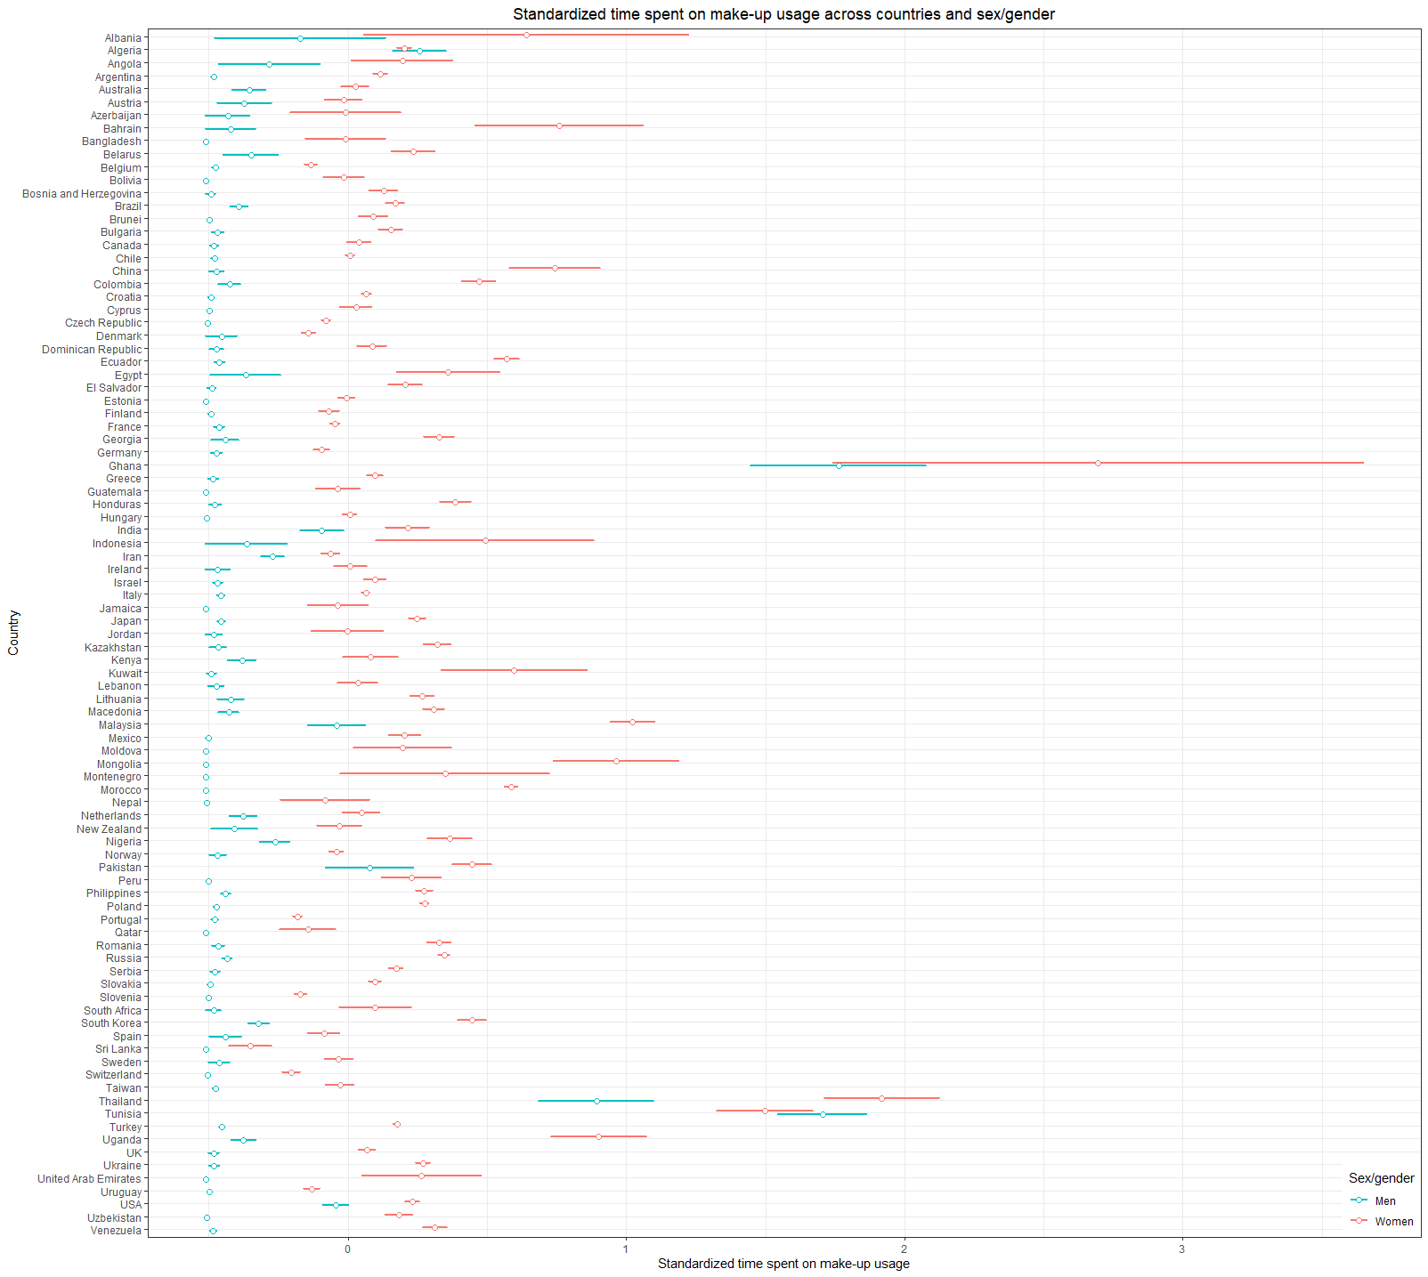

Note. Error bars represent 95% confidence interval

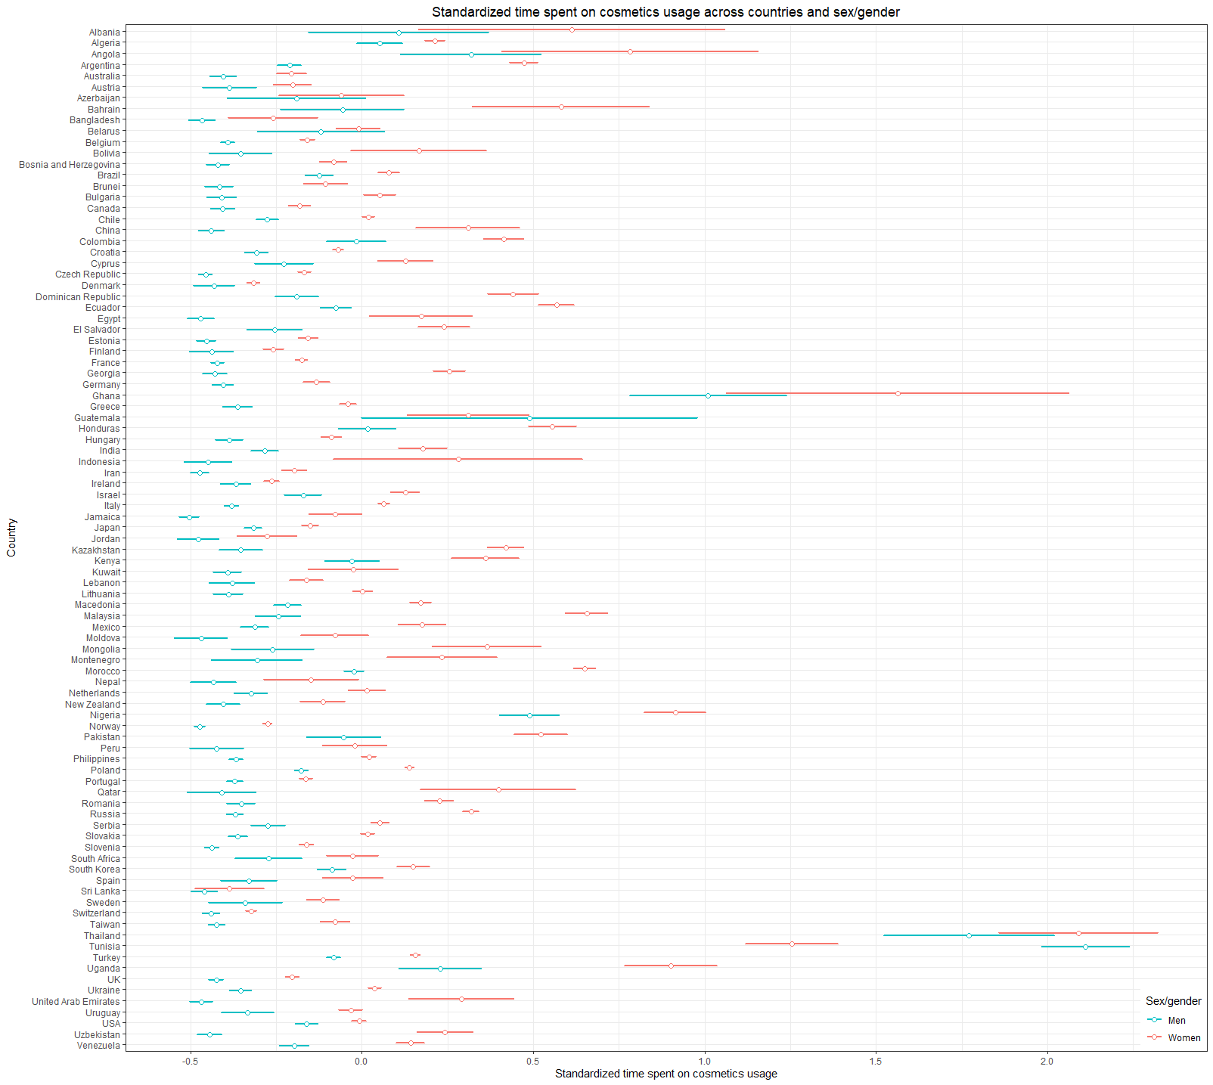Figure S3. Standardized time spent on cosmetics usage across countries and sex.

Note. Error bars represent 95% confidence intervals.

# Figure S4. Standardized time spent exercising across countries and sex.

Note. Error bars represent 95% confidence intervals.

# Figure S5. Standardized time spent on hair grooming across countries and sex.

Note. Error bars represent 95% confidence intervals.

# Figure S6. Standardized time spent on body hygiene across countries and sex.

Note. Error bars represent 95% confidence intervals.

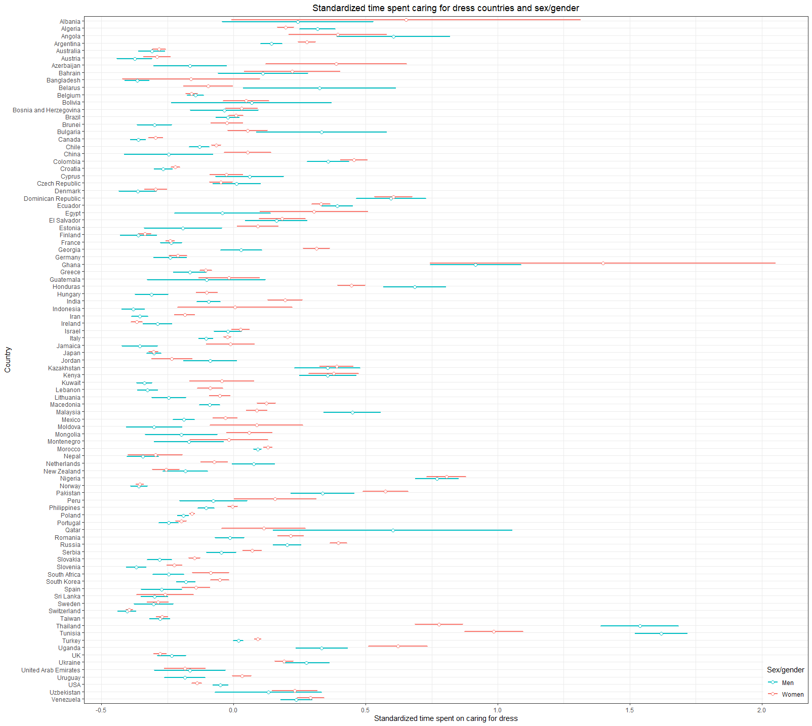

# Figure S7. Standardized time spent caring for dress across countries and sex.

Note. Error bars represent 95% confidence intervals.

# Figure S8. Standardized time spent caring for diet across countries and sex.

Note. Error bars represent 95% confidence intervals.

# Figure S9. Standardized time spent on other activities aimed to increase one’s physical attractiveness across countries and sex.

Note. Error bars represent 95% confidence intervals.

# Table S3. Results of measurements of equivalence of invariance with respect to gender equality.

|  |  |  |  |  |  |
| --- | --- | --- | --- | --- | --- |
|  | **ΔCFI** | **ΔTLI** | **ΔRMSEA** | **ΔSRMR** | **Invariance reached?** |
| Metric | 0.003 | 0.005 | 0.029 | 0.022 | Yes |
| Scalar | 0.051 | 0.036 | 0.053 | 0.028 | No |
| Partial Scalar | 0.012 | 0.017 | 0.031 | 0.003 | Yes |

# Table S4. Results of measurements of equivalence of invariance with respect to individualism.

|  |  |  |  |  |  |
| --- | --- | --- | --- | --- | --- |
|  | **ΔCFI** | **ΔTLI** | **ΔRMSEA** | **ΔSRMR** | **Invariance reached?** |
| Metric | 0.004 | 0.006 | 0.035 | 0.020 | Yes |
| Scalar | 0.128 | 0.094 | 0.113 | 0.062 | No |
| Partial Scalar | 0.003 | 0.004 | 0.013 | 0.006 | Yes |

# Table S5. Results of the multilevel linear model regressing time spent on beauty-enhancing behaviors (the basic index with four categories) on countries’ Gross Domestic Product (GDP) per capita, countries’ individualism score, countries’ gender equality score, countries’ pathogen prevalence score, sex, age, age2, relationship status, time spent on social media, watching TV, self-assessed attractiveness, attained education, socioeconomic status, political views, individual-level individualism score, individual-level traditional gender roles score, and individual-level history of pathogenic diseases, with participants nested within countries.

|  |  |  |  |  |  |  |
| --- | --- | --- | --- | --- | --- | --- |
| **Fixed effects** | ***β*** | | **SE** | **95% CI** | ***p*** | |
| **Country-level predictors** |  | |  |  |  | |
| GDP (per capita) | - | 0.030 | 0.033 | [-0.035, 0.095] |  | 0.370 |
| Country’s Individualism | - | 0.041 | 0.029 | [-0.098, 0.017] |  | 0.166 |
| Country’s Gender Equality | - | 0.077 | 0.028 | [-0.132, -0.021] |  | 0.007 |
| Country’s Pathogen Prevalence |  | 0.054 | 0.028 | [-0.002, 0.109] |  | 0.060 |
| **Individual-level predictors** |  |  |  |  |  |  |
| Sex/Gender a |  | 0.168 | 0.013 | [ 0.142, 0.194] | < | 0.001 |
| Age | - | 0.080 | 0.021 | [-0.120, -0.039] | < | 0.001 |
| Age2 |  | 0.091 | 0.019 | [ 0.054, 0.127] | < | 0.001 |
| Relationship Status b |  | 0.010 | 0.004 | [ 0.004, 0.017] |  | 0.003 |
| Time Watching TV |  | 0.073 | 0.003 | [ 0.067, 0.080] | < | 0.001 |
| Time on Social Media |  | 0.142 | 0.004 | [ 0.135, 0.149] | < | 0.001 |
| Self-assessed Attractiveness |  | 0.049 | 0.003 | [ 0.043, 0.056] | < | 0.001 |
| Individualism |  | 0.015 | 0.003 | [ 0.008, 0.021] | < | 0.001 |
| Traditional gender roles | - | 0.125 | 0.004 | [-0.132, -0.118] | < | 0.001 |
| Individual Pathogen History |  | 0.073 | 0.003 | [ 0.066, 0.079] | < | 0.001 |
| Education | - | 0.041 | 0.004 | [-0.048, -0.034] | < | 0.001 |
| Political Views |  | 0.026 | 0.003 | [ 0.019, 0.032] | < | 0.001 |
| Socioeconomic Status |  | 0.027 | 0.003 | [ 0.020, 0.034] | < | 0.001 |
| **Random Effects** | **Variance** | | **SD** |  |  | |
| Intercept |  | 0.014 | 0.118 |  |  |  |
| Sex |  | 0.029 | 0.170 |  |  |  |
| Age |  | 0.002 | 0.046 |  |  |  |

*Note*. a–Men as a reference group. b–Single individuals as a reference group. *ICC* = 0.026, dfresiduals = 69526, deviance = 149000.1, *r*2 = 0.083, all VIFs below 6.07 (*M* = 2.02, *SD* = 1.62).

# Table S6. Results of the multilevel linear model regressing time spent exercising on countries’ Gross Domestic Product (GDP) per capita, countries’ individualism score, countries’ gender equality score, countries’ pathogen prevalence score, sex, age, age2, relationship status, time spent on social media, watching TV, self-assessed attractiveness, attained education, socioeconomic status, political views, individual-level individualism score, individual-level traditional gender roles score, and individual-level history of pathogenic diseases, with participants nested within countries.

|  |  |  |  |  |  |  |
| --- | --- | --- | --- | --- | --- | --- |
| **Fixed effects** | ***β*** | | **SE** | **95% CI** | ***p*** | |
| **Country-level predictors** |  | |  |  |  | |
| GDP (per capita) |  | 0.012 | 0.027 | [-0.041, 0.064] |  | 0.663 |
| Country’s Individualism | - | 0.029 | 0.024 | [-0.076, 0.018] |  | 0.223 |
| Country’s Gender Equality | - | 0.006 | 0.024 | [-0.052, 0.041] |  | 0.815 |
| Country’s Pathogen Prevalence |  | 0.017 | 0.023 | [-0.029, 0.063] |  | 0.465 |
| **Individual-level predictors** |  |  |  |  |  |  |
| Sex/Gender a | - | 0.139 | 0.010 | [-0.157, -0.120] | < | 0.001 |
| Age | - | 0.113 | 0.022 | [-0.156, -0.070] | < | 0.001 |
| Age2 |  | 0.072 | 0.020 | [ 0.033, 0.110] | < | 0.001 |
| Relationship Status b |  | 0.002 | 0.004 | [-0.010, 0.005] |  | 0.557 |
| Time Watching TV |  | 0.014 | 0.004 | [ 0.007, 0.022] | < | 0.001 |
| Time on Social Media |  | 0.049 | 0.004 | [ 0.042, 0.057] | < | 0.001 |
| Self-assessed Attractiveness |  | 0.118 | 0.004 | [ 0.111, 0.125] | < | 0.001 |
| Individualism |  | 0.009 | 0.004 | [ 0.002, 0.016] |  | 0.010 |
| Gender Equality | - | 0.069 | 0.004 | [-0.076, -0.062] | < | 0.001 |
| Individual Pathogen History |  | 0.029 | 0.004 | [ 0.022, 0.036] | < | 0.001 |
| Education |  | 0.018 | 0.004 | [ 0.011, 0.026] | < | 0.001 |
| Political Views |  | 0.026 | 0.004 | [ 0.019, 0.033] | < | 0.001 |
| Socioeconomic Status |  | 0.060 | 0.004 | [ 0.053, 0.067] | < | 0.001 |
| **Random Effects** | **Variance** | | **SD** |  |  | |
| Intercept |  | 0.055 | 0.234 |  |  |  |
| Sex |  | 0.019 | 0.141 |  |  |  |
| Age |  | 0.004 | 0.062 |  |  |  |

*Note*. a–Men as a reference group. b–Single individuals as a reference group. *ICC* = 0.059, dfresiduals = 71081, deviance = 190694.2, *r*2 = 0.085, all VIFs below 5.81 (*M* = 1.97, *SD* = 1.53).

# Table S7. Results of the multilevel linear model regressing time spent enhancing physical attractiveness (the extended index with eight categories) on variables of interest, with interactions with gender (participants were nested within countries).

|  |  |  |  |  |  |  |
| --- | --- | --- | --- | --- | --- | --- |
| **Fixed effects** | ***β*** | | **SE** | **95% CI** | ***p*** | |
| **Country-level predictors** |  | |  |  |  | |
| GDP (per capita) | - | 0.059 | 0.043 | [-0.144, 0.026] |  | 0.172 |
| Country’s Individualism | - | 0.066 | 0.039 | [-0.142, 0.010] |  | 0.090 |
| Country’s Gender Equality | - | 0.063 | 0.037 | [-0.135, 0.009] |  | 0.088 |
| Country’s Pathogen Prevalence |  | 0.005 | 0.038 | [-0.069, 0.079] |  | 0.894 |
| **Individual-level predictors** |  |  |  |  |  |  |
| Gender a |  | 0.082 | 0.009 | [ 0.064, 0.100] | < | 0.001 |
| Age | - | 0.110 | 0.021 | [-0.152, -0.068] | < | 0.001 |
| Age2 |  | 0.122 | 0.019 | [ 0.085, 0.159] | < | 0.001 |
| Relationship Status b |  | 0.013 | 0.004 | [ 0.006, 0.020] | < | 0.001 |
| Individual Pathogen History |  | 0.054 | 0.004 | [ 0.047, 0.061] | < | 0.001 |
| Traditional gender roles | - | 0.127 | 0.004 | [-0.135, -0.120] | < | 0.001 |
| Time on Social Media |  | 0.143 | 0.004 | [ 0.136, 0.150] | < | 0.001 |
| Time Watching TV |  | 0.065 | 0.003 | [ 0.059, 0.072] | < | 0.001 |
| Individualism |  | 0.017 | 0.003 | [ 0.010, 0.024] | < | 0.001 |
| Self-assessed Attractiveness |  | 0.089 | 0.003 | [ 0.082, 0.096] | < | 0.001 |
| Education | - | 0.026 | 0.004 | [-0.033, -0.019] | < | 0.001 |
| Political Views |  | 0.032 | 0.003 | [ 0.025, 0.039] | < | 0.001 |
| Socioeconomic Status | - | 0.026 | 0.004 | [-0.033, -0.019] | < | 0.001 |
| **Interactions with Sex** |  |  |  |  |  |  |
| GDP (per capita) * Gender | - | 0.030 | 0.015 | [-0.059, -0.001] |  | 0.039 |
| Country’s Individualism * Gender | - | 0.010 | 0.013 | [-0.035, 0.015] |  | 0.428 |
| Country’s Gender Equality * Gender |  | 0.005 | 0.013 | [-0.020, 0.030] |  | 0.669 |
| Country’s Pathogen Prevalence * Gender |  | -0.024 | 0.012 | [-0.048, 0.000] |  | 0.049 |
| Age * Gender | - | 0.077 | 0.019 | [-0.114, -0.040] | < | 0.001 |
| Age2 * Gender |  | 0.085 | 0.018 | [ 0.049, 0.121] | < | 0.001 |
| Relationship Status b * Gender |  | 0.004 | 0.004 | [-0.003, 0.011] |  | 0.312 |
| Individual Pathogen History * Gender | - | 0.005 | 0.003 | [-0.011, 0.001] |  | 0.128 |
| Traditional gender roles * Gender | - | 0.015 | 0.003 | [-0.022, -0.008] | < | 0.001 |
| Time on Social Media * Gender | - | 0.008 | 0.004 | [-0.015, -0.001] |  | 0.028 |
| Time Watching TV * Gender |  | 0.009 | 0.003 | [ 0.002, 0.016] |  | 0.008 |
| Individualism * Gender |  | 0.005 | 0.003 | [-0.002, 0.012] |  | 0.137 |
| Self-assessed Attractiveness * Gender | - | 0.015 | 0.003 | [-0.022, -0.008] | < | 0.001 |
| Education * Gender | - | 0.011 | 0.003 | [-0.018, -0.004] |  | 0.002 |
| Political Views * Gender |  | 0.015 | 0.003 | [ 0.009, 0.022] | < | 0.001 |
| Socioeconomic Status * Gender | - | 0.003 | 0.003 | [-0.010, 0.004] |  | 0.348 |
| **Random Effects** | **Variance** | | **SD** |  |  | |
| Intercept |  | 0.026 | 0.162 |  |  |  |
| Gender |  | 0.015 | 0.123 |  |  |  |
| Age |  | 0.004 | 0.068 |  |  |  |

*Note*. a–Men as a reference group. b–Single individuals as a reference group, Age2–Age squared, *ICC* = 0.036, Pseudo *r*2 = 0.221, dfresiduals = 71065, deviance = 176183.8, all VIFs below 6.08 (*M* = 1.96, *SD* = 1.12).

# Table S8. Results of the multilevel linear model regressing time spent enhancing physical attractiveness on freed first-level predictors, with participants nested within countries.

|  |  |  |  |  |  |  |
| --- | --- | --- | --- | --- | --- | --- |
| **Fixed effects** | ***β*** | | **SE** | **95% CI** | ***p*** | |
| **Country-level predictors** |  | |  |  |  | |
| GDP (per capita) | - | 0.021 | 0.028 | [-0.075, 0.034] |  | 0.460 |
| Country’s Individualism | - | 0.062 | 0.025 | [-0.110, -0.013] |  | 0.013 |
| Country’s Gender Equality | - | 0.062 | 0.024 | [-0.109, -0.014] |  | 0.012 |
| Country’s Pathogen Prevalence | - | 0.009 | 0.024 | [-0.056, 0.037] |  | 0.688 |
| **Individual-level predictors** |  |  |  |  |  |  |
| Gender a |  | 0.084 | 0.009 | [ 0.067, 0.101] | < | 0.001 |
| Age | - | 0.125 | 0.021 | [-0.167, -0.083] | < | 0.001 |
| Age2 |  | 0.137 | 0.019 | [ 0.100, 0.174] | < | 0.001 |
| Relationship Status b |  | 0.007 | 0.005 | [-0.002, 0.017] |  | 0.122 |
| Time Watching TV |  | 0.057 | 0.005 | [ 0.047, 0.067] | < | 0.001 |
| Time on Social Media |  | 0.135 | 0.008 | [ 0.120, 0.150] | < | 0.001 |
| Self-assessed Attractiveness |  | 0.087 | 0.006 | [ 0.075, 0.099] | < | 0.001 |
| Individualism |  | 0.017 | 0.004 | [ 0.009, 0.026] | < | 0.001 |
| Gender Equality | - | 0.111 | 0.009 | [-0.129, -0.093] | < | 0.001 |
| Individual Pathogen History |  | 0.060 | 0.010 | [ 0.040, 0.080] | < | 0.001 |
| Education | - | 0.023 | 0.007 | [-0.037, -0.009] | < | 0.001 |
| Political Views |  | 0.032 | 0.005 | [ 0.023, 0.041] | < | 0.001 |
| Socioeconomic Status |  | 0.084 | 0.009 | [ 0.067, 0.101] | < | 0.001 |
| **Random Effects** | **Variance** | | **SD** |  |  | |
| Intercept |  | 0.035 | 0.187 |  |  |  |
| Gender a |  | 0.015 | 0.123 |  |  |  |
| Age |  | 0.005 | 0.068 |  |  |  |
| Relationship Status b |  | 0.002 | 0.044 |  |  |  |
| Time Watching TV |  | 0.001 | 0.025 |  |  |  |
| Time on Social Media |  | 0.002 | 0.047 |  |  |  |
| Self-assessed Attractiveness |  | 0.001 | 0.034 |  |  |  |
| Individualism |  | 0.000 | 0.018 |  |  |  |
| Gender Equality |  | 0.004 | 0.061 |  |  |  |
| Individual Pathogen History |  | 0.005 | 0.072 |  |  |  |
| Education |  | 0.002 | 0.043 |  |  |  |
| Political Views |  | 0.000 | 0.019 |  |  |  |
| Socioeconomic Status |  | 0.002 | 0.039 |  |  |  |

*Note*. a–Men as a reference category, b–Single individuals as a reference group. *ICC* = 0.049, dfresiduals = 70996, deviance = 175183.2, Pseudo *r*2 = 0.180.

# Table S9. Results of the multilevel linear model regressing time spent enhancing physical attractiveness among men, with participants nested within countries.

|  |  |  |  |  |  |  |
| --- | --- | --- | --- | --- | --- | --- |
| **Fixed effects** | ***β*** | | **SE** | **95% CI** | ***p*** | |
| **Country-level predictors** |  | |  |  |  | |
| GDP (per capita) | - | 0.016 | 0.038 | [-0.091, 0.058] |  | 0.671 |
| Country’s Individualism | - | 0.044 | 0.034 | [-0.111, 0.022] |  | 0.191 |
| Country’s Gender Equality | - | 0.080 | 0.034 | [-0.146, -0.013] |  | 0.019 |
| Country’s Pathogen Prevalence |  | 0.040 | 0.034 | [-0.027, 0.106] |  | 0.24 |
| **Individual-level predictors** |  |  |  |  |  |  |
| Age | - | 0.005 | 0.034 | [-0.061, 0.072] |  | 0.881 |
| Age2 | - | 0.001 | 0.032 | [-0.064, 0.062] |  | 0.974 |
| Relationship Status a |  | 0.008 | 0.006 | [-0.004, 0.020] |  | 0.202 |
| Time Watching TV |  | 0.052 | 0.006 | [ 0.040, 0.064] | < | 0.001 |
| Time on Social Media |  | 0.148 | 0.006 | [ 0.136, 0.160] | < | 0.001 |
| Self-assessed Attractiveness |  | 0.110 | 0.006 | [ 0.099, 0.122] | < | 0.001 |
| Individualism |  | 0.009 | 0.006 | [-0.002, 0.021] |  | 0.106 |
| Gender Equality | - | 0.121 | 0.006 | [-0.133, -0.109] | < | 0.001 |
| Individual Pathogen History |  | 0.075 | 0.006 | [ 0.064, 0.086] | < | 0.001 |
| Education | - | 0.010 | 0.006 | [-0.022, 0.002] |  | 0.100 |
| Political Views |  | 0.010 | 0.006 | [-0.002, 0.022] |  | 0.101 |
| Socioeconomic Status |  | 0.055 | 0.006 | [ 0.043, 0.067] | < | 0.001 |
| **Random Effects** | **Variance** | | **SD** |  |  | |
| Intercept |  | 0.026 | 0.161 |  |  |  |
| Age |  | 0.004 | 0.060 |  |  |  |

*Note*. a–Single individuals as a reference group. *ICC* = 0.036, dfresiduals = 23062, deviance = 56874.4, Pseudo *r*2 = 0.215, all VIFs below 3.16 (*M* = 1.38, *SD* = 0.67).

# Table S10. Results of the multilevel linear model regressing time spent enhancing physical attractiveness among women, with participants nested within countries.

|  |  |  |  |  |  |  |
| --- | --- | --- | --- | --- | --- | --- |
| **Fixed effects** | ***β*** | | **SE** | **95% CI** | ***p*** | |
| **Country-level predictors** |  | |  |  |  | |
| GDP (per capita) | - | 0.093 | 0.04 | [-0.172, -0.015] |  | 0.019 |
| Country’s Individualism | - | 0.057 | 0.036 | [-0.127, 0.013] |  | 0.112 |
| Country’s Gender Equality | - | 0.056 | 0.034 | [-0.122, 0.010] |  | 0.096 |
| Country’s Pathogen Prevalence |  | 0.031 | 0.034 | [-0.036, 0.098] |  | 0.368 |
| **Individual-level predictors** |  |  |  |  |  |  |
| Age | - | 0.165 | 0.026 | [-0.216, -0.114] | < | 0.001 |
| Age2 | - | 0.181 | 0.023 | [ 0.135, 0.227] | < | 0.001 |
| Relationship Status a |  | 0.015 | 0.004 | [ 0.006, 0.023] | < | 0.001 |
| Time Watching TV |  | 0.072 | 0.004 | [ 0.064, 0.080] | < | 0.001 |
| Time on Social Media |  | 0.139 | 0.004 | [ 0.130, 0.147] | < | 0.001 |
| Self-assessed Attractiveness |  | 0.079 | 0.004 | [ 0.071, 0.087] | < | 0.001 |
| Individualism |  | 0.021 | 0.004 | [ 0.013, 0.029] | < | 0.001 |
| Gender Equality | - | 0.123 | 0.004 | [-0.131, -0.114] | < | 0.001 |
| Individual Pathogen History |  | 0.043 | 0.004 | [ 0.035, 0.052] | < | 0.001 |
| Education | - | 0.033 | 0.005 | [-0.042, -0.024] | < | 0.001 |
| Political Views |  | 0.043 | 0.004 | [ 0.034, 0.051] | < | 0.001 |
| Socioeconomic Status |  | 0.046 | 0.004 | [ 0.038, 0.054] | < | 0.001 |
| **Random Effects** | **Variance** | | **SD** |  |  | |
| Intercept |  | 0.031 | 0.176 |  |  |  |
| Age |  | 0.005 | 0.073 |  |  |  |

*Note*. a–Single individuals as a reference group. *ICC* = 0.059, dfresiduals = 47999, deviance = 119343.82, Pseudo *r*2 = 0.146, all VIFs below 2.28 (*M* = 1.29, *SD* = 0.43).

# Figure S10. Standardized predicted time spent enhancing physical attractiveness across gender and age (controlling for other predictors from the model, see Table S7).

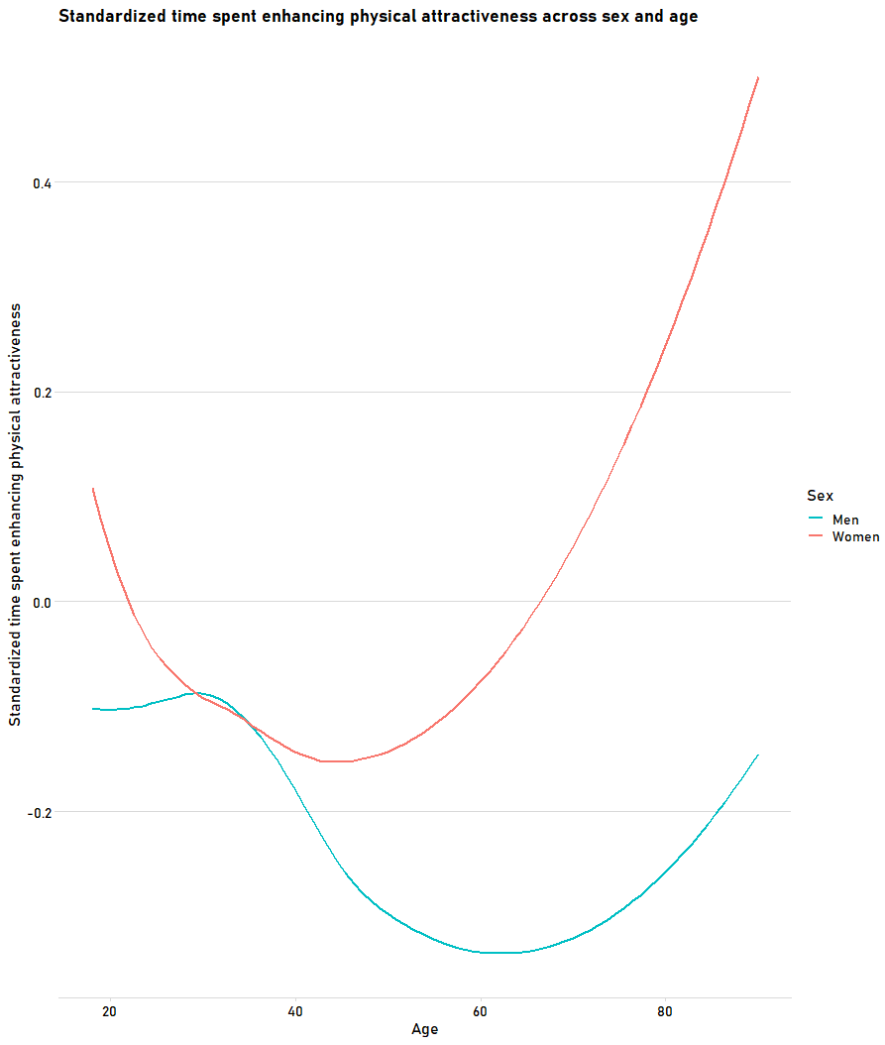

# Figure S11. Standardized predicted time spent enhancing physical attractiveness across gender and relationship status (controlling for other predictors from the model, see Table S7).

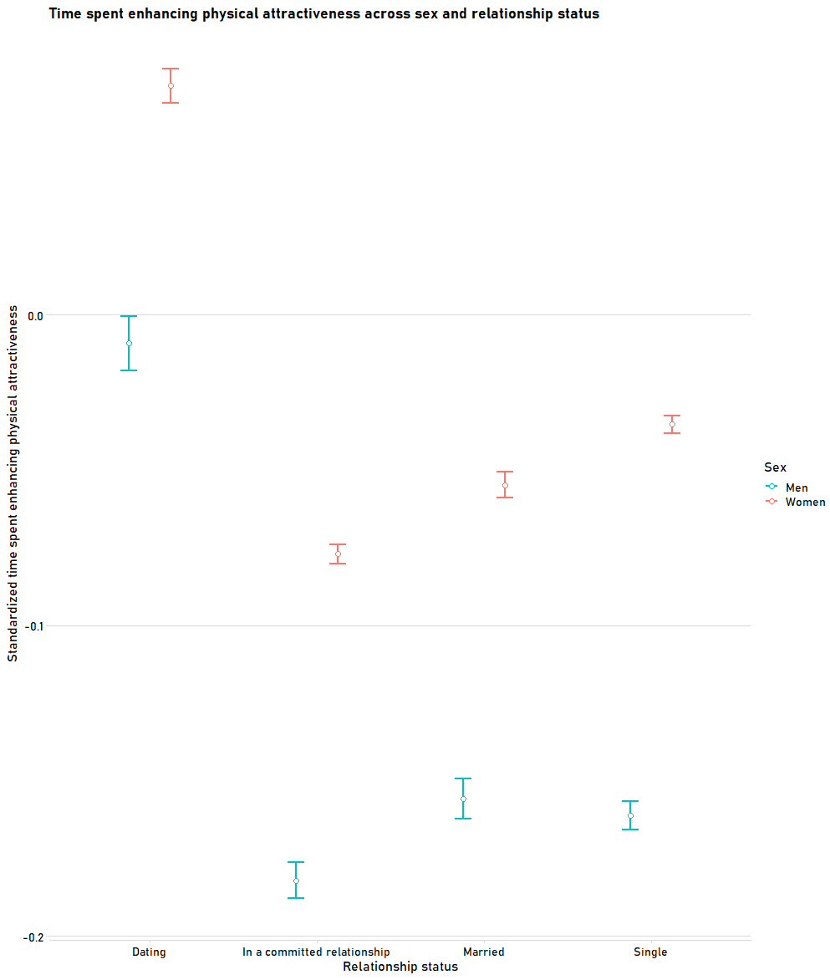

# Figure S12. Standardized predicted time spent enhancing physical attractiveness across gender and time spent watching TV (controlling for other predictors from the model, see Table S7).

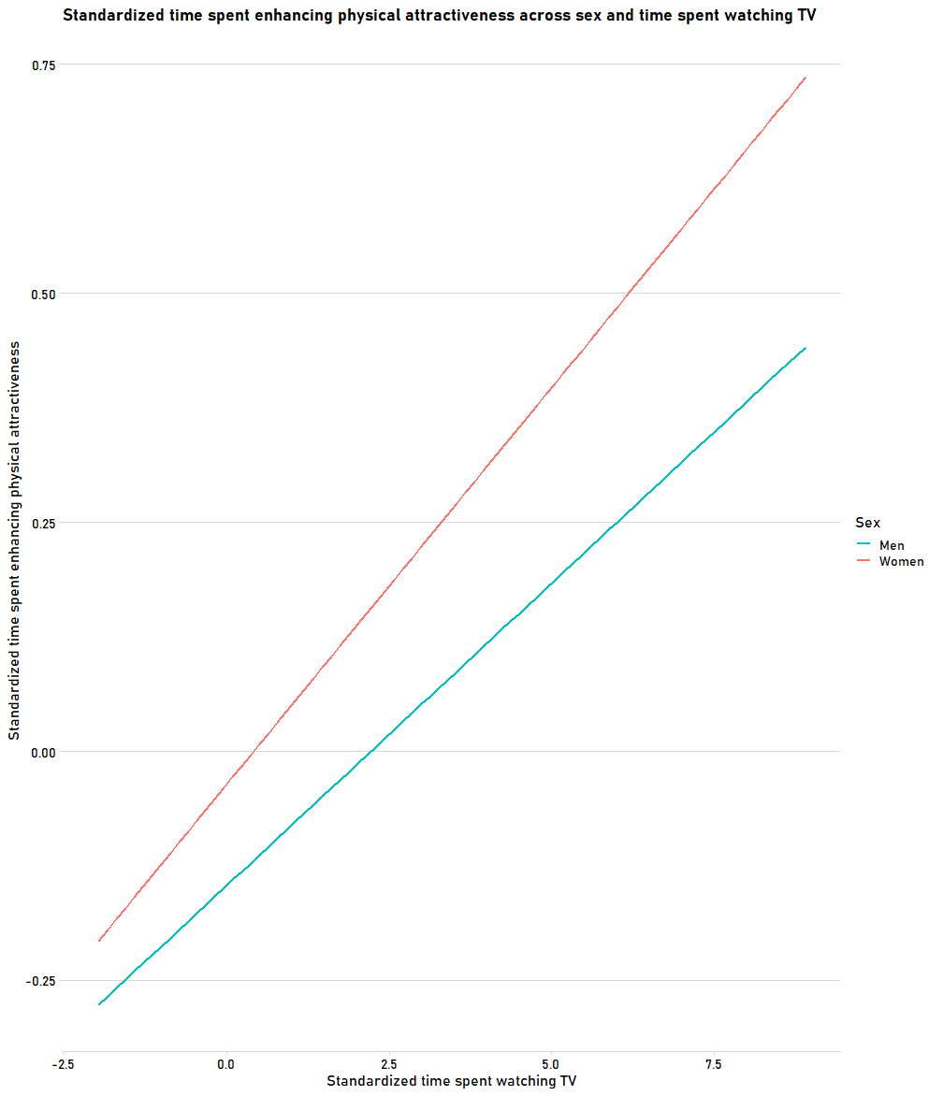

# Figure S13. Standardized predicted time spent enhancing physical attractiveness across gender and time spent on social media (controlling for other predictors from the model, see Table S7).

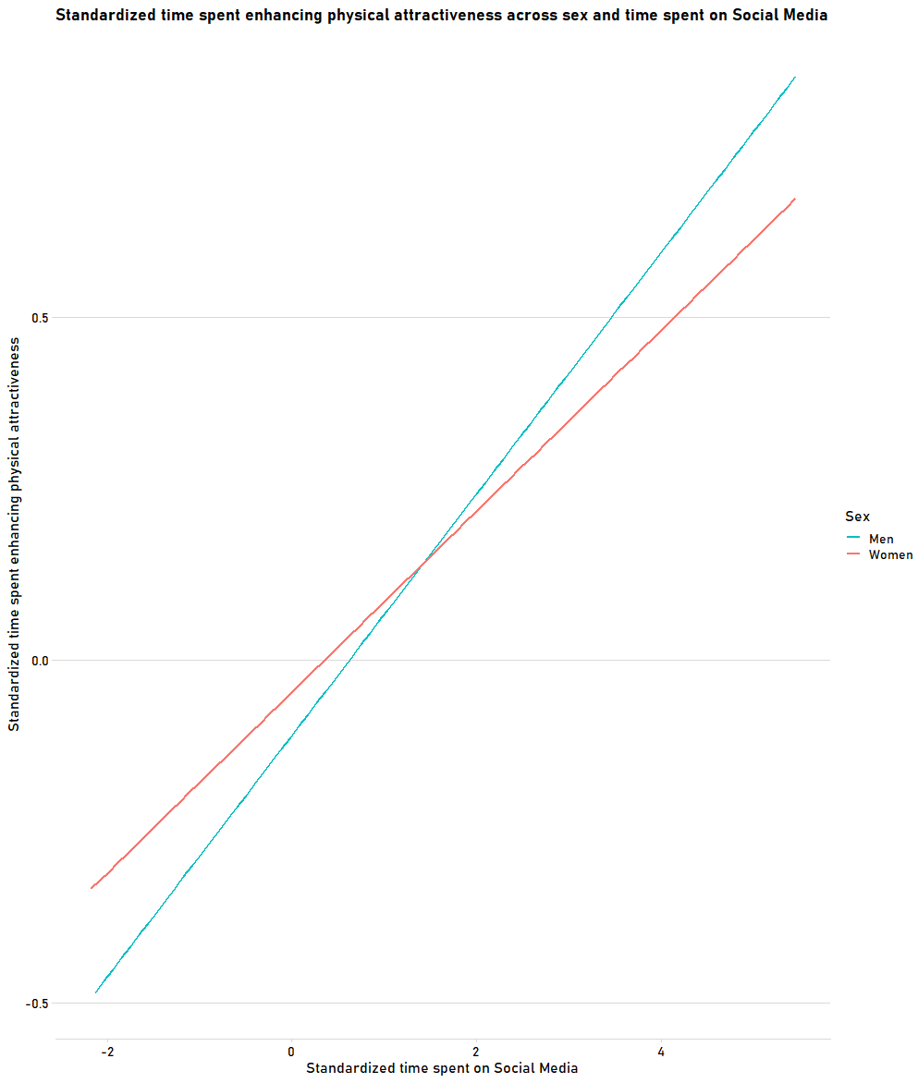

# Figure S14. Standardized predicted time spent enhancing physical attractiveness across gender and self-assessed physical attractiveness (controlling for other predictors from the model, see Table S7).

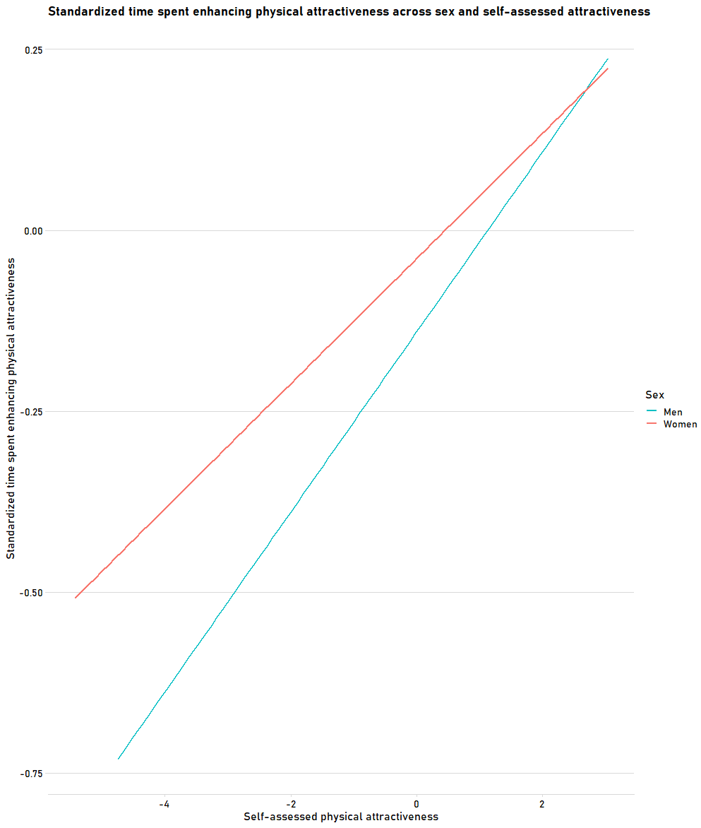

# Figure S15. Standardized predicted time spent enhancing physical attractiveness across gender and participants’ endorsement of gender roles (controlling for other predictors from the model, see Table S7).

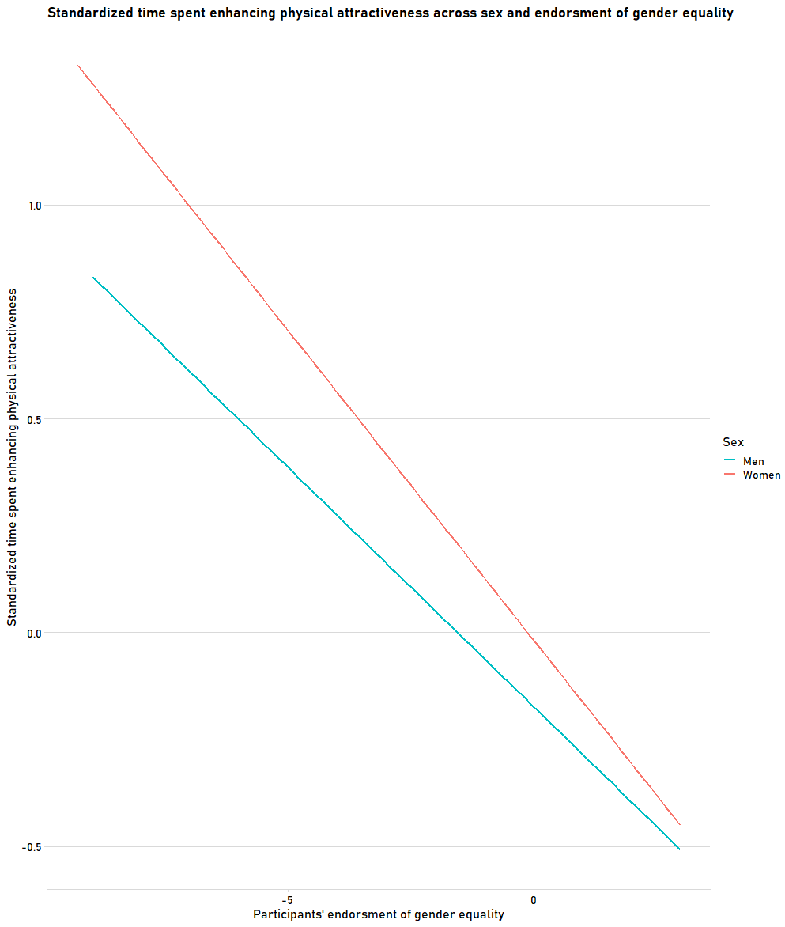

# Figure S16. Standardized predicted time spent enhancing physical attractiveness across gender and participants’ attained level of education (controlling for other predictors from the model, see Table S7).

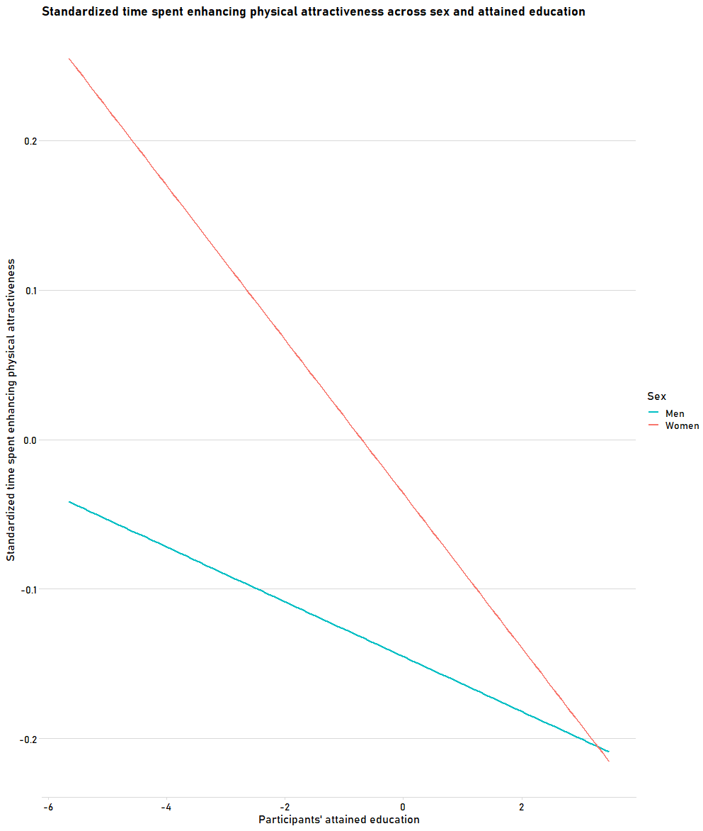

# Figure S17. Standardized predicted time spent enhancing physical attractiveness across gender and participants’ political beliefs (controlling for other predictors from the model, see Table S7).

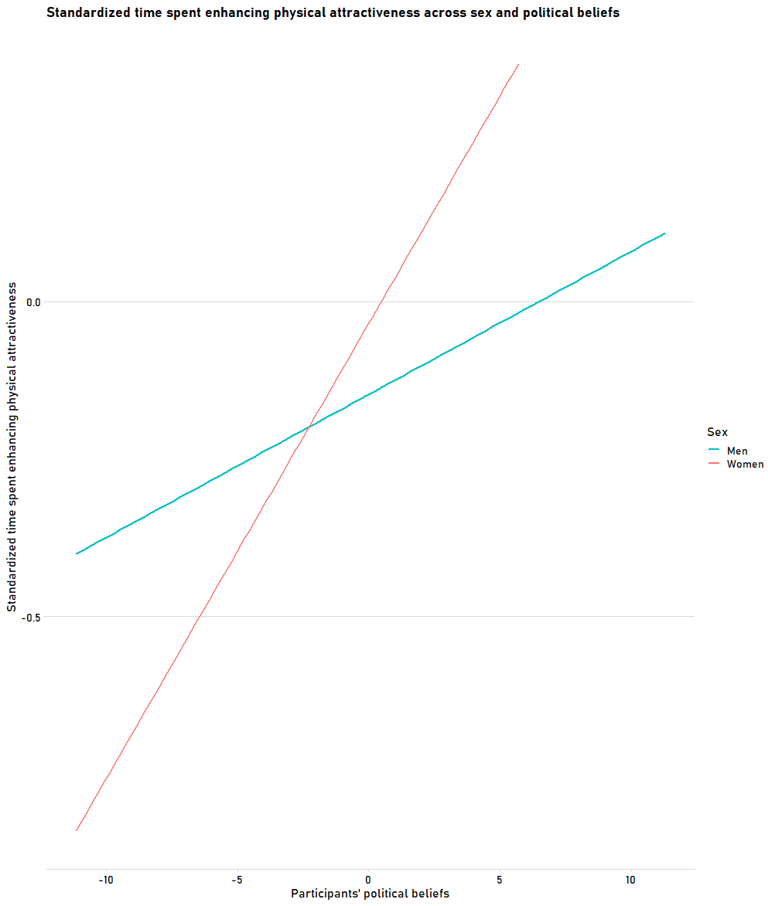

# Figure S18. Standardized predicted time spent enhancing physical attractiveness across gender and countries’ gross domestic product (GDP) per capita (controlling for other predictors from the model, see Table S7).

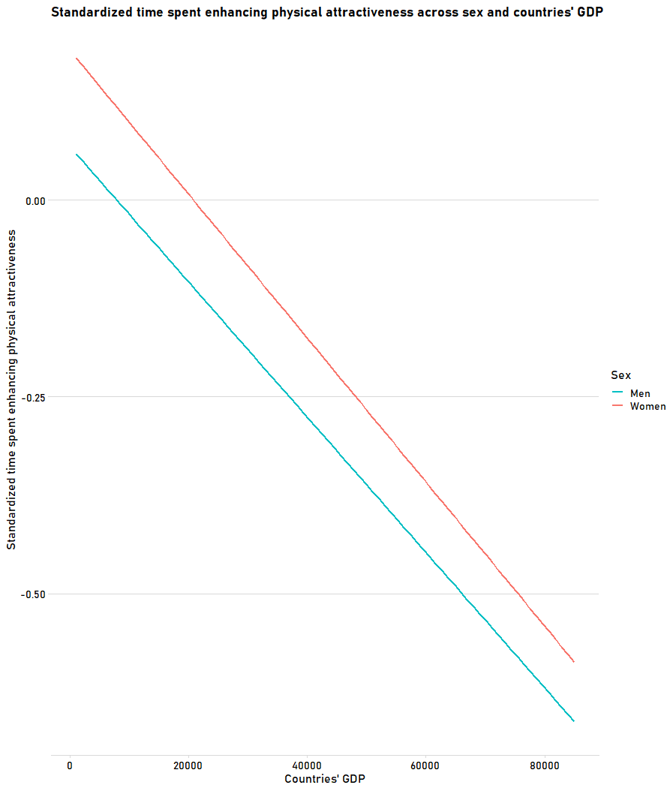

# Figure S19. Standardized predicted time spent enhancing physical attractiveness across gender and countries’ historic pathogen prevalence (controlling for other predictors from the model, see Table S7).

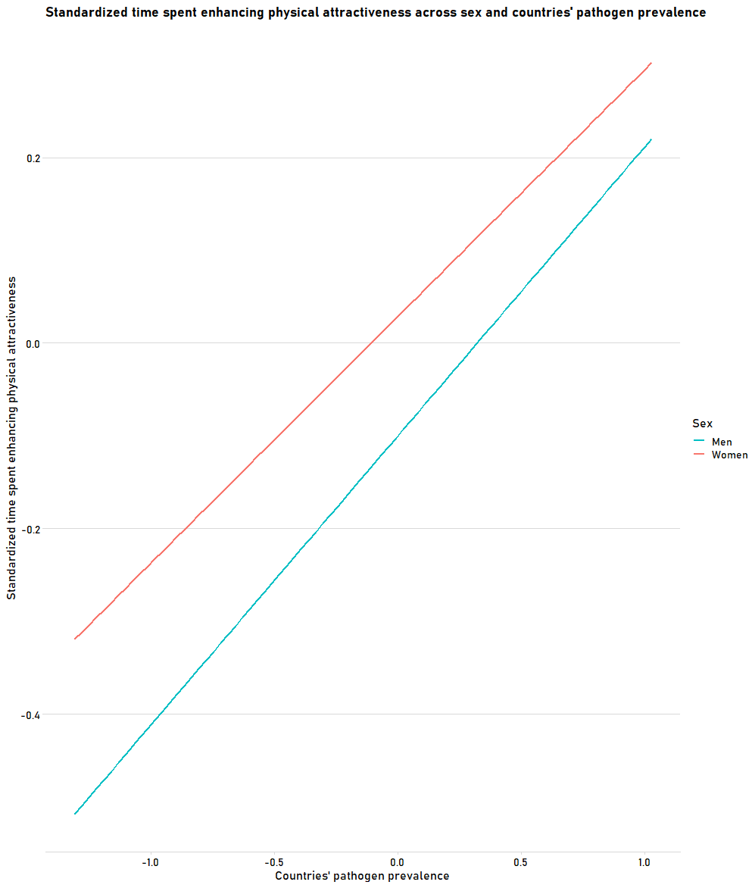

# Table S11. Results of the multilevel linear model regressing time spent enhancing physical attractiveness on variables of interest with the addition of quadratic self-assessed physical attractiveness, with participants nested within countries.

|  |  |  |  |  |  |  |
| --- | --- | --- | --- | --- | --- | --- |
| **Fixed effects** | ***β*** | | **SE** | **95% CI** | ***p*** | |
| **Country-level predictors** |  | |  |  |  | |
| GDP (per capita) | - | 0.020 | 0.038 | [-0.095, 0.056] |  | 0.610 |
| Country’s Individualism | - | 0.049 | 0.034 | [-0.116, 0.018] |  | 0.155 |
| Country’s Gender Equality | - | 0.069 | 0.033 | [-0.133, -0.006] |  | 0.033 |
| Country’s Pathogen Prevalence |  | 0.043 | 0.033 | [-0.022, 0.108] |  | 0.193 |
| **Individual-level predictors** |  |  |  |  |  |  |
| Gender a |  | 0.084 | 0.01 | [ 0.065, 0.103] | < | 0.001 |
| Age | - | 0.101 | 0.021 | [-0.143, -0.059] | < | 0.001 |
| Age2 |  | 0.113 | 0.019 | [ 0.076, 0.150] | < | 0.001 |
| Relationship Status b |  | 0.014 | 0.004 | [ 0.007, 0.021] | < | 0.001 |
| Time Watching TV |  | 0.065 | 0.003 | [ 0.058, 0.072] | < | 0.001 |
| Time on Social Media |  | 0.139 | 0.004 | [ 0.132, 0.146] | < | 0.001 |
| Self-assessed Attractiveness | - | 0.214 | 0.015 | [-0.243, -0.184] | < | 0.001 |
| Self-assessed Attractiveness^2 |  | 0.311 | 0.015 | [ 0.282, 0.341] | < | 0.001 |
| Individualism |  | 0.013 | 0.003 | [ 0.007, 0.020] | < | 0.001 |
| Gender Equality | - | 0.119 | 0.004 | [-0.126, -0.112] | < | 0.001 |
| Individual Pathogen History |  | 0.054 | 0.003 | [ 0.048, 0.061] | < | 0.001 |
| Education | - | 0.024 | 0.004 | [-0.032, -0.017] | < | 0.001 |
| Political Views |  | 0.031 | 0.003 | [ 0.024, 0.038] | < | 0.001 |
| Socioeconomic Status |  | 0.048 | 0.003 | [ 0.042, 0.055] | < | 0.001 |
| **Random Effects** | **Variance** | | **SD** |  |  | |
| Intercept |  | 0.031 | 0.175 |  |  |  |
| Age |  | 0.005 | 0.071 |  |  |  |

*Note*. a–Men as a reference group, b–Single individuals as a reference group. *ICC* = 0.037, dfresiduals = 71080, deviance = 175900.5, Pseudo *r*2 = 0.168.

# Figure S20. Non-linear relationship between standardized time spent enhancing one’s physical attractiveness and self-assessed physical attractiveness.

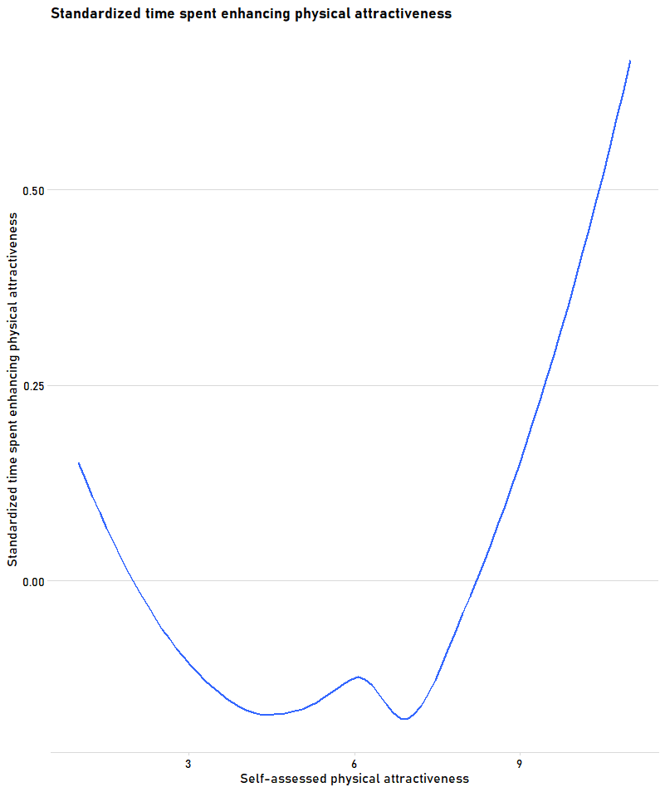

# Table S12. Results of the multilevel linear model regressing the first factor of activities aimed at increasing one’s physical attractiveness on predictor variables (with participants nested within countries).

|  |  |  |  |  |  |  |
| --- | --- | --- | --- | --- | --- | --- |
| **Fixed effects** | ***β*** | | **SE** | **95% CI** | ***p*** | |
| **Country-level predictors** |  | |  |  |  | |
| GDP (per capita) | - | 0.016 | 0.021 | [-0.056, 0.024] |  | 0.435 |
| Country’s Individualism | - | 0.022 | 0.018 | [-0.057, 0.014] |  | 0.239 |
| Country’s Gender Equality | - | 0.075 | 0.018 | [-0.110, -0.040] | < | 0.001 |
| Country’s Pathogen Prevalence | - | 0.001 | 0.018 | [-0.036, 0.033] |  | 0.942 |
| **Individual-level predictors** |  |  |  |  |  |  |
| Gender a |  | 0.021 | 0.007 | [ 0.007, 0.034] |  | 0.002 |
| Age |  | 0.011 | 0.022 | [-0.033, 0.054] |  | 0.624 |
| Age2 |  | 0.025 | 0.020 | [-0.015, 0.065] |  | 0.224 |
| Relationship Status b |  | 0.017 | 0.004 | [ 0.009, 0.024] | < | 0.001 |
| Time Watching TV |  | 0.035 | 0.004 | [ 0.028, 0.042] | < | 0.001 |
| Time on Social Media |  | 0.073 | 0.004 | [ 0.066, 0.081] | < | 0.001 |
| Self-assessed Attractiveness |  | 0.043 | 0.004 | [ 0.035, 0.050] | < | 0.001 |
| Individualism |  | 0.005 | 0.004 | [-0.002, 0.013] |  | 0.146 |
| Gender Equality | - | 0.059 | 0.004 | [-0.066, -0.051] | < | 0.001 |
| Individual Pathogen History |  | 0.026 | 0.004 | [ 0.019, 0.033] | < | 0.001 |
| Education | - | 0.010 | 0.004 | [-0.018, -0.003] |  | 0.009 |
| Political Views |  | 0.011 | 0.004 | [ 0.003, 0.018] |  | 0.005 |
| Socioeconomic Status |  | 0.033 | 0.004 | [ 0.025, 0.040] | < | 0.001 |
| **Random Effects** | **Variance** | | **SD** |  |  | |
| Intercept |  | 0.032 | 0.180 |  |  |  |
| Gender |  | 0.038 | 0.197 |  |  |  |
| Age |  | 0.004 | 0.064 |  |  |  |

*Note*. a–Men as a reference category, b–Single individuals as a reference group. *ICC* = 0.043, dfresiduals = 70932, deviance = 177999.9, Pseudo *r*2 = 0.183, all VIFs below 2.23 (*M* = 1.27, *SD* = 0.41).

# Table S13. Results of the multilevel linear model regressing the second factor of activities aimed at increasing one’s physical attractiveness on predictor variables (with participants nested within countries).

|  |  |  |  |  |  |  |
| --- | --- | --- | --- | --- | --- | --- |
| **Fixed effects** | ***β*** | | **SE** | **95% CI** | ***p*** | |
| **Country-level predictors** |  | |  |  |  | |
| GDP (per capita) | - | 0.069 | 0.026 | [-0.121, -0.018] |  | 0.008 |
| Country’s Individualism | - | 0.010 | 0.023 | [-0.056, 0.035] |  | 0.648 |
| Country’s Gender Equality | - | 0.075 | 0.023 | [-0.121, -0.030] | < | 0.001 |
| Country’s Pathogen Prevalence | - | 0.021 | 0.022 | [-0.064, 0.023] |  | 0.351 |
| **Individual-level predictors** |  |  |  |  |  |  |
| Age |  | 0.018 | 0.007 | [ 0.005, 0.032] |  | 0.005 |
| Age2 | - | 0.106 | 0.028 | [-0.160, -0.051] | < | 0.001 |
| Gender a |  | 0.120 | 0.025 | [ 0.070, 0.170] | < | 0.001 |
| Relationship Status b |  | 0.016 | 0.005 | [ 0.006, 0.025] | < | 0.001 |
| Time Watching TV |  | 0.054 | 0.005 | [ 0.044, 0.063] | < | 0.001 |
| Time on Social Media |  | 0.092 | 0.005 | [ 0.082, 0.101] | < | 0.001 |
| Self-assessed Attractiveness |  | 0.016 | 0.005 | [ 0.007, 0.025] | < | 0.001 |
| Individualism |  | 0.007 | 0.005 | [-0.002, 0.016] |  | 0.126 |
| Gender Equality | - | 0.057 | 0.005 | [-0.067, -0.048] | < | 0.001 |
| Individual Pathogen History |  | 0.026 | 0.005 | [ 0.017, 0.035] | < | 0.001 |
| Education | - | 0.027 | 0.005 | [-0.036, -0.017] | < | 0.001 |
| Political Views |  | 0.008 | 0.005 | [-0.001, 0.017] |  | 0.091 |
| Socioeconomic Status |  | 0.012 | 0.005 | [ 0.003, 0.021] |  | 0.010 |
| **Random Effects** | **Variance** | | **SD** |  |  | |
| Intercept |  | 0.010 | 0.100 |  |  |  |
| Gender |  | 0.002 | 0.048 |  |  |  |
| Age |  | 0.005 | 0.071 |  |  |  |

*Note*. a–Men as a reference category, b–Single individuals as a reference group. *ICC* = 0.011, dfresiduals = 45274, deviance = 124097.5, Pseudo *r*2 = 0.043, all VIFs below 2.59 (*M* = 1.31, *SD* = 0.49).

# Time spent on beauty enhancing behaviors across men and women

Women spent, on average, 243 minutes a day enhancing their attractiveness (including all eight types of behaviors), while men–228. If exercising was excluded, women spent, on average, 211, while men 182.

# Figure S21. Time spent on cosmetics usage across age.

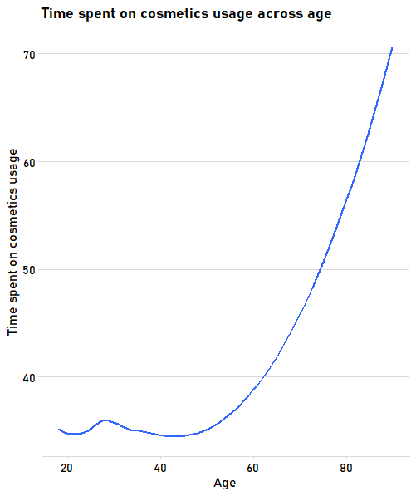

# Figure S22. Time spent on makeup usage across age (among women).

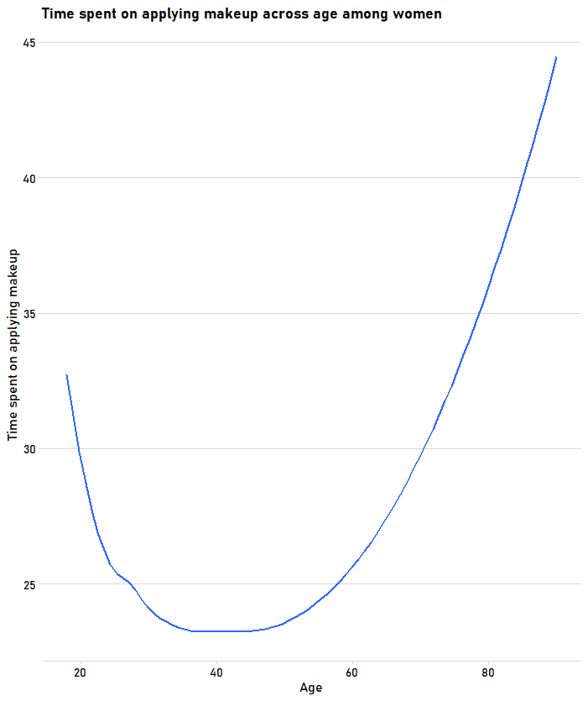

# Figure S23. Time spent caring for hygiene across age.

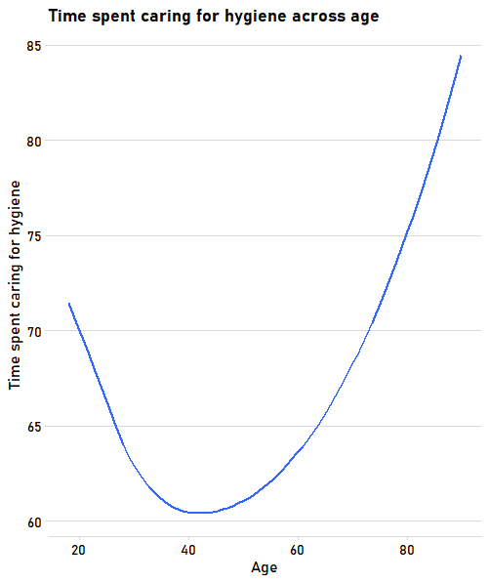

# Figure S24. Time spent caring for hair across age.

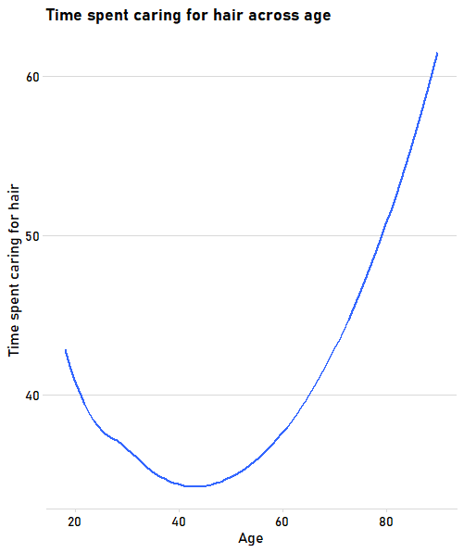

# Figure S25. Time spent exercising across age.

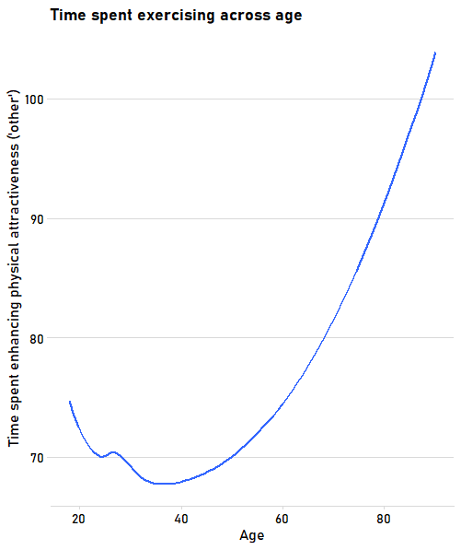

# Figure S26. Time spent caring for dress across age.

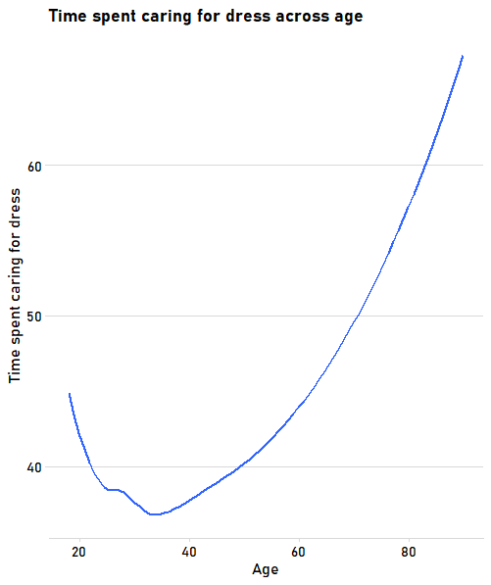

# Figure S27. Time spent caring for diet across age.

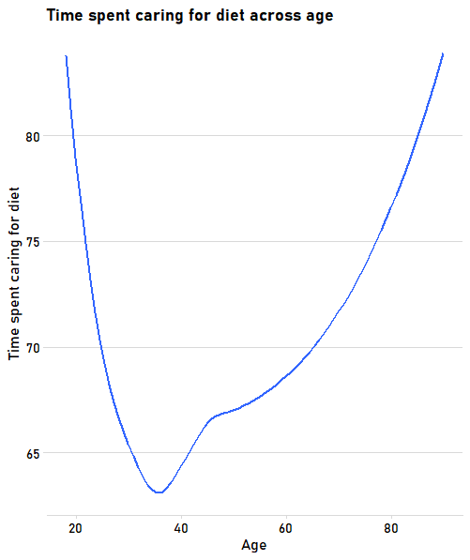

# Figure S28. Time spent on other activities aimed at increasing one’s attractiveness across age.

Asd

# Survey

What is your **gender**?

* Male (0)
* Female (1)
* Non-binary / third gender (2)
* Prefer not to say (3)

How **old are you** (in years)?

* 18 (18)
* 19 (19)
* 20 (20)
* 21 (21)
* 22 (22)
* 23 (23)
* 24 (24)
* 25 (25)
* 26 (26)
* 27 (27)
* 28 (28)
* 29 (29)
* 30 (30)
* 31 (31)
* 32 (32)
* 33 (33)
* 34 (34)
* 35 (35)
* 36 (36)
* 37 (37)
* 38 (38)
* 39 (39)
* 40 (40)
* 41 (41)
* 42 (42)
* 43 (43)
* 44 (44)
* 45 (45)
* 46 (46)
* 47 (47)
* 48 (48)
* 49 (49)
* 50 (50)
* 51 (51)
* 52 (52)
* 53 (53)
* 54 (54)
* 55 (55)
* 56 (56)
* 57 (57)
* 58 (58)
* 59 (59)
* 60 (60)
* 61 (61)
* 62 (62)
* 63 (63)
* 64 (64)
* 65 (65)
* 66 (66)
* 67 (67)
* 68 (68)
* 69 (69)
* 70 (70)
* 71 (71)
* 72 (72)
* 73 (73)
* 74 (74)
* 75 (75)
* 76 (76)
* 77 (77)
* 78 (78)
* 79 (78)
* 80 (80)
* 81 (81)
* 82 (82)
* 83 (83)
* 84 (84)
* 85 (85)
* 86 (86)
* 87 (87)
* 88 (88)
* 89 (89)
* 90 or more (90)

Where do you **currently live**?

* Afghanistan (1)
* Albania (2)
* Algeria (3)
* Andorra (4)
* Angola (5)
* Antigua and Barbuda (6)
* Argentina (7)
* Armenia (8)
* Australia (9)
* Austria (10)
* Azerbaijan (11)
* Bahamas (12)
* Bahrain (13)
* Bangladesh (14)
* Barbados (15)
* Belarus (16)
* Belgium (17)
* Belize (18)
* Benin (19)
* Bhutan (20)
* Bolivia (21)
* Bosnia and Herzegovina (22)
* Botswana (23)
* Brazil (24)
* Brunei Darussalam (25)
* Bulgaria (26)
* Burkina Faso (27)
* Burundi (28)
* Cambodia (29)
* Cameroon (30)
* Canada (31)
* Cape Verde (32)
* Central African Republic (33)
* Chad (34)
* Chile (35)
* China (36)
* Colombia (37)
* Comoros (38)
* Congo, Republic of the... (39)
* Costa Rica (40)
* Côte d'Ivoire (41)
* Croatia (42)
* Cuba (43)
* Cyprus (44)
* Czech Republic (45)
* Democratic People's Republic of Korea (46)
* Democratic Republic of the Congo (47)
* Denmark (48)
* Djibouti (49)
* Dominica (50)
* Dominican Republic (51)
* Ecuador (52)
* Egypt (53)
* El Salvador (54)
* Equatorial Guinea (55)
* Eritrea (56)
* Estonia (57)
* Ethiopia (58)
* Fiji (59)
* Finland (60)
* France (61)
* Gabon (62)
* Gambia (63)
* Georgia (64)
* Germany (65)
* Ghana (66)
* Greece (67)
* Grenada (68)
* Guatemala (69)
* Guinea (70)
* Guinea-Bissau (71)
* Guyana (72)
* Haiti (73)
* Honduras (74)
* Hong Kong (S.A.R.) (75)
* Hungary (76)
* Iceland (77)
* India (78)
* Indonesia (79)
* Iran, Islamic Republic of... (80)
* Iraq (81)
* Ireland (82)
* Israel (83)
* Italy (84)
* Jamaica (85)
* Japan (86)
* Jordan (87)
* Kazakhstan (88)
* Kenya (89)
* Kiribati (90)
* Kuwait (91)
* Kyrgyzstan (92)
* Lao People's Democratic Republic (93)
* Latvia (94)
* Lebanon (95)
* Lesotho (96)
* Liberia (97)
* Libyan Arab Jamahiriya (98)
* Liechtenstein (99)
* Lithuania (100)
* Luxembourg (101)
* Madagascar (102)
* Malawi (103)
* Malaysia (104)
* Maldives (105)
* Mali (106)
* Malta (107)
* Marshall Islands (108)
* Mauritania (109)
* Mauritius (110)
* Mexico (111)
* Micronesia, Federated States of... (112)
* Monaco (113)
* Mongolia (114)
* Montenegro (115)
* Morocco (116)
* Mozambique (117)
* Myanmar (118)
* Namibia (119)
* Nauru (120)
* Nepal (121)
* Netherlands (122)
* New Zealand (123)
* Nicaragua (124)
* Niger (125)
* Nigeria (126)
* North Korea (127)
* Norway (128)
* Oman (129)
* Pakistan (130)
* Palau (131)
* Panama (132)
* Papua New Guinea (133)
* Paraguay (134)
* Peru (135)
* Philippines (136)
* Poland (137)
* Portugal (138)
* Qatar (139)
* Republic of Korea (140)
* Republic of Moldova (141)
* Romania (142)
* Russian Federation (143)
* Rwanda (144)
* Saint Kitts and Nevis (145)
* Saint Lucia (146)
* Saint Vincent and the Grenadines (147)
* Samoa (148)
* San Marino (149)
* Sao Tome and Principe (150)
* Saudi Arabia (151)
* Senegal (152)
* Serbia (153)
* Seychelles (154)
* Sierra Leone (155)
* Singapore (156)
* Slovakia (157)
* Slovenia (158)
* Solomon Islands (159)
* Somalia (160)
* South Africa (161)
* South Korea (162)
* Spain (163)
* Sri Lanka (164)
* Sudan (165)
* Suriname (166)
* Swaziland (167)
* Sweden (168)
* Switzerland (169)
* Syrian Arab Republic (170)
* Tajikistan (171)
* Thailand (172)
* The former Yugoslav Republic of Macedonia (173)
* Timor-Leste (174)
* Togo (175)
* Tonga (176)
* Trinidad and Tobago (177)
* Tunisia (178)
* Turkey (179)
* Turkmenistan (180)
* Tuvalu (181)
* Uganda (182)
* Ukraine (183)
* United Arab Emirates (184)
* United Kingdom of Great Britain and Northern Ireland (185)
* United Republic of Tanzania (186)
* United States of America (187)
* Uruguay (188)
* Uzbekistan (189)
* Vanuatu (190)
* Venezuela, Bolivarian Republic of... (191)
* Viet Nam (192)
* Yemen (193)
* Zambia (580)
* Zimbabwe (1357)
* Somaliland (1358)
* Kosovo (1359)
* Palestine (1360)
* Taiwan (1361)

What is your **relationship status**?

* Single (0)
* Dating (1)
* In a committed relationship (2)
* Married (3)

How much time, on average, do you spend on **Social Media** each day?

|  |  |  |
| --- | --- | --- |
|  | 0 | 360 |

|  |  |
| --- | --- |
| Number of minutes: () |  |

How much time, on average, do you spend **watching TV** (including online TV, such as Netflix, HBO, YouTube) each day?

|  |  |  |
| --- | --- | --- |
|  | 0 | 360 |

|  |  |
| --- | --- |
| Number of minutes: () |  |

How much do you agree with the following statements?

|  |  |  |  |  |  |  |  |
| --- | --- | --- | --- | --- | --- | --- | --- |
|  | definitely disagree |  |  |  |  |  | definitely agree |

|  |  |  |  |  |  |  |  |
| --- | --- | --- | --- | --- | --- | --- | --- |
|  | 1 | 2 | 3 | 4 | 5 | 6 | 7 |

|  |  |
| --- | --- |
| A woman’s most important role is to take care of her home and cook. () |  |
| Changing diapers, giving kids a bath, and feeding kids are the mother’s responsibility. () |  |
| A man should have the final word about decisions in his home. () |  |

|  |  |  |  |  |  |  |  |
| --- | --- | --- | --- | --- | --- | --- | --- |
|  | definitely disagree |  |  |  |  |  | definitely agree |

|  |  |  |  |  |  |  |  |
| --- | --- | --- | --- | --- | --- | --- | --- |
|  | 1 | 2 | 3 | 4 | 5 | 6 | 7 |

|  |  |
| --- | --- |
| Group welfare is more important than individual rewards. () |  |
| Group success is more important than individual success. () |  |
| Being accepted by the members of the workgroup is very important. () |  |
| Employees should pursue their goals only after considering the welfare of the group. () |  |

Have you ever **contracted** (been sick with) any of the following **diseases**?

|  |  |  |  |
| --- | --- | --- | --- |
|  | Never (0) | Once (1) | Multiple times (2) |
| Leishmanias |  |  |  |
| Schistosomes |  |  |  |
| Trypanosomes |  |  |  |
| Leprosy |  |  |  |
| Malaria |  |  |  |
| Typhus |  |  |  |
| Filariae |  |  |  |
| Dengue |  |  |  |
| Tuberculosis |  |  |  |

How **important** is it for you to **look attractive**?

|  |  |  |  |  |  |  |  |  |  |
| --- | --- | --- | --- | --- | --- | --- | --- | --- | --- |
|  | not at all important | 2 | 3 | 4 | 5 | 6 | 7 | 8 | extremely important |

|  |  |  |  |  |  |  |  |  |  |
| --- | --- | --- | --- | --- | --- | --- | --- | --- | --- |
|  | 1 | 2 | 3 | 4 | 5 | 6 | 7 | 8 | 9 |

|  |  |
| --- | --- |
| () |  |

Which of these activities do you perform to look better?  
    
*Please* ***do not check*** *an activity if you perform it* ***only for other******reasons*** *than looking better (e.g., you brush your teeth ONLY to stay healthy, and not because you both want to look attractive AND stay healthy; or you exercise to work on your problems with your back, and not to look more attractive).*

|  |  |  |
| --- | --- | --- |
|  | Yes (1) | No (0) |
| 1. Applying make-up (Attract_which_makeup) |  |  |
| 2. Body hygiene (please, think of all the things you do to care for your body hygiene, including washing your Arms, body, brushing or flossing your teeth, etc.) (Attract_which_hyg) |  |  |
| 3. Using cosmetics (please, think of all the cosmetics you are using, e.g., body lotion, hand cream, face cream, etc.) (Attract_which_cosmet) |  |  |
| 4. Exercising (e.g., running, doing aerobics, working out at the gym or working out at home, weightlifting, building your muscles) (Attract_which_exercise) |  |  |
| 5. Hair grooming (e.g., caring for hair, brushing, washing, styling) (Attract_which_hair) |  |  |
| 6. Dressing nicely (e.g., wearing clothes that make you look better) (Attract_which_dress) |  |  |
| 7. Caring for diet (e.g., slimming, gaining weight) (Attract_which_diet) |  |  |
| 8. Other: (Attract_which_other) |  |  |

*Think about your typical day and the things you do to look attractive. How much time do you spend on the following activities [in minutes]:*  
**Applying make-up [in minutes/hours]**

|  |  |  |
| --- | --- | --- |
|  | 0 | 360 |

|  |  |
| --- | --- |
| Number of minutes: () |  |

How important is applying make-up for you in increasing your attractiveness?

|  |  |  |  |  |  |  |
| --- | --- | --- | --- | --- | --- | --- |
|  | 1 (1) | 2 (2) | 3 (3) | 4 (4) | 5 (5) |  |
| not at all important |  |  |  |  |  | very important |

*Think about your typical day and the things you do to look attractive. How much time do you spend on the following activities [in minutes]:*  
**Body hygiene** (please, think of all the things you do to care for your body hygiene, including washing your Arms, body, brushing or flossing your teeth, etc.) [in minutes/hours]

|  |  |  |
| --- | --- | --- |
|  | 0 | 360 |

|  |  |
| --- | --- |
| Number of minutes: () |  |

How important is body hygiene for you in increasing your attractiveness?

|  |  |  |  |  |  |  |
| --- | --- | --- | --- | --- | --- | --- |
|  | 1 (1) | 2 (2) | 3 (3) | 4 (4) | 5 (5) |  |
| not at all important |  |  |  |  |  | very important |

*Think about your typical day and the things you do to look attractive. How much time do you spend on:*  
**Using cosmetics** (please, think of all the cosmetics you are using, e.g., body lotion, hand cream, face cream, etc.) [in minutes/hours]

|  |  |  |
| --- | --- | --- |
|  | 0 | 360 |

|  |  |
| --- | --- |
| Number of minutes: () |  |

How important is using cosmetics for you in increasing your attractiveness?

|  |  |  |  |  |  |  |
| --- | --- | --- | --- | --- | --- | --- |
|  | 1 (1) | 2 (2) | 3 (3) | 4 (4) | 5 (5) |  |
| not at all important |  |  |  |  |  | very important |

*Think about your typical day and the things you do to look attractive. How much time do you spend on:*  
**Exercising** (e.g., running, doing aerobics, working out at the gym or working out at home, weightlifting, building your muscles) [in minutes/hours]

|  |  |  |
| --- | --- | --- |
|  | 0 | 360 |

|  |  |
| --- | --- |
| Number of minutes: () |  |

How important is exercising for you in increasing your attractiveness?

|  |  |  |  |  |  |  |
| --- | --- | --- | --- | --- | --- | --- |
|  | 1 (1) | 2 (2) | 3 (3) | 4 (4) | 5 (5) |  |
| not at all important |  |  |  |  |  | very important |

*Think about your typical day and the things you do to look attractive. How much time do you spend on:*  
**Hair grooming** (e.g., caring for hair, brushing, washing, styling) [in minutes/hours]

|  |  |  |
| --- | --- | --- |
|  | 0 | 360 |

|  |  |
| --- | --- |
| Number of minutes: () |  |

How important is hair grooming for you in increasing your attractiveness?

|  |  |  |  |  |  |  |
| --- | --- | --- | --- | --- | --- | --- |
|  | 1 (1) | 2 (2) | 3 (3) | 4 (4) | 5 (5) |  |
| not at all important |  |  |  |  |  | very important |

*Think about your typical day and the things you do to look attractive. How much time do you spend on:*  
**Dressing nicely** (e.g., wearing clothes that make you look better) [in minutes/hours]

|  |  |  |
| --- | --- | --- |
|  | 0 | 360 |

|  |  |
| --- | --- |
| Number of minutes: () |  |

How important is dressing nicely for you in increasing your attractiveness?

|  |  |  |  |  |  |  |
| --- | --- | --- | --- | --- | --- | --- |
|  | 1 (1) | 2 (2) | 3 (3) | 4 (4) | 5 (5) |  |
| not at all important |  |  |  |  |  | very important |

*Think about your typical day and the things you do to look attractive. How much time do you spend on:*  
**Caring for diet** (e.g., slimming, gaining weight) [in minutes/hours]

|  |  |  |
| --- | --- | --- |
|  | 0 | 360 |

|  |  |
| --- | --- |
| Number of minutes: () |  |

How important is caring for diet for you in increasing your attractiveness?

|  |  |  |  |  |  |  |
| --- | --- | --- | --- | --- | --- | --- |
|  | 1 (1) | 2 (2) | 3 (3) | 4 (4) | 5 (5) |  |
| not at all important |  |  |  |  |  | very important |

*Think about your typical day and the things you do to look attractive. How much time do you spend on:*  
**${Attract_which_activ/ChoiceTextEntryValue/8}** [in minutes/hours]

|  |  |  |
| --- | --- | --- |
|  | 0 | 360 |

|  |  |
| --- | --- |
| Number of minutes: () |  |

How important is ${Attract_which_activ/ChoiceTextEntryValue/8} for you in increasing your attractiveness?

|  |  |  |  |  |  |  |
| --- | --- | --- | --- | --- | --- | --- |
|  | 1 (1) | 2 (2) | 3 (3) | 4 (4) | 5 (5) |  |
| not at all important |  |  |  |  |  | very important |

How **physically attractive**are you?

* **Extremely physically unattractive** (Bottom 1 out of 100 people) (1)
* (Bottom 3 out of 100 people) (2)
* (Bottom 8 out of 100 people) (3)
* (Bottom 18 out of 100 people) (4)
* (Bottom 32 out of 100 people) (5)
* **Average** (Top 50 out of 100 people) (6)
* (Top 32 out of 100 people) (7)
* (Top 18 out of 100 people) (8)
* (Top 8 out of 100 people) (9)
* (Top 3 out of 100 people) (10)
* **Extremely physically attractive** (Top 1 out of 100 people) (11)

Which of the following answers best describes **your l**evel of education?

* No formal education (1)
* Primary school only (2)
* Primary school through Secondary school (3)
* Primary school through High school or Technical college (4)
* Primary school through Bachelor's degree (5)
* Primary school through Master's degree (6)
* Primary school through PhD, MD, JD, or other advanced degree (7)

Which of the following answers best describes **your political views**?

* far left political views (1)
* center left political views (2)
* center political views (3)
* center right political views (4)
* far right political views (5)

Which of the following answers best describes **your social class level**?

* upper class (1)
* upper middle class (2)
* middle class (3)
* lower middle class (4)
* lower class (5)